OpenWIS Installation Guide

Written by :  Alexia Audevart  Yannick Lizzi  Leon Mika  François Faugeron  Yves Goupil  Martin Gollogly | Diffused to :
Authorized by : OpenWIS Association

DOCUMENT MODIFICATIONS

Vers. | Date | Modified Paragraphs | Comments
01.0 | 17/11/2010 |  | Document creation
02.8 | 23/02/2015 |  | Up to iteration 3.13
02.9 | 05/05/2015 | 3, 7.5 | OpenAM Migration
02.9 | 25/11/2015 | 3.1.4, 3.2.4 | SsoAdminTools conf
03.0 | 05/02/2016 |  | Up to iteration 3.14.2

TABLE OF CONTENTS

1 Introduction 6
1.1 Document structure 6
1.2 Installation Process 6
1.3 Maintenance Process 8
2 Pre-Requisites 10
2.1 System Environment 10
2.2 Hostname Configuration 10
2.3 User 10
2.4 Java Installation 11
2.4.1 RPM install 11
2.4.2 Set Environment variables 11
2.5 Tuning system limits 11
3 Security service 13
3.1 OpenDJ 13
3.1.1 GUI Installation 13
3.1.2 Command Line Installation 18
3.1.3 Start / Stop OpenDS 20
3.1.4 Failover considerations 21
3.1.5 Import OpenWIS schema 22
3.2 OpenAM 22
3.2.1 Deploy OpenAM in Tomcat 22
3.2.2 OpenAM installation 23
3.2.3 Check OpenAM / OpenDJ connectivity 31
3.2.4 Add OpenWIS User attributes 33
3.2.5 Front-end and Failover considerations 34
3.3 OpenWiS Security Configuration 36
3.3.1 Create Hosted Identity Provider 36
3.3.2 Register a remote Identity Provider 38
3.3.3 IdpDiscovery 40
3.3.4 Register a remote Service Provider 42
3.3.5 Assertion Processing Attributes 47
3.3.6 Customize OpenAM Login Pages 48
3.4 OpenWiS Security Services (User and Group management) 48
3.4.1 Front-end and Failover considerations 49
3.5 Initialize Centre in LDAP 49
3.6 Firewall considerations 50
3.7 Logs and errors 50
4 Postgresql 52
4.1 Install Postgresql 52
4.2 Setting Up The Database 53
4.3 Installing The OpenWIS Schema 55
4.4 Failover considerations 56
4.5 Firewall considerations 58
5 Data Service 59
5.1 Installing The Data Services 59
5.1.1 Preparing The Environment 59
5.1.2 Configuring the Data Services 61
5.2 Cache Replication 67
5.2.1 Replication mechanism 67
5.2.2 Deploy the OpenWIS Dispatcher 68
5.2.3 Deploy the FTP Replication 69
5.2.4 Replication deployment across several hosts 72
5.2.5 Throughput considerations 72
5.3 CRON based purge 72
5.4 Failover considerations 73
5.4.1 FTP Replication failover 73
5.5 Firewall considerations 74
5.6 Monitoring 74
5.6.1 JMS Queues 74
5.6.2 Data Service folders 76
5.7 Logs and errors 76
6 Management Service 77
6.1 Deploy the Management Service 77
6.2 Failover considerations 77
6.3 Firewall considerations 77
6.4 Logs and errors 77
7 Portals 79
7.1 Tomcat installation 79
7.1.1 Start / Stop Tomcat 80
7.1.2 Failover considerations 80
7.2 Solr 81
7.2.1 Configuration 81
7.2.2 Failover considerations 82
7.2.3 Logs and errors 83
7.3 User and Admin portal 83
7.3.1 Deployment of the Web applications 83
7.3.2 Configuration 83
7.3.3 Failover considerations 86
7.3.4 Portal customization 86
7.3.5 CRON purge 87
7.3.6 Logs and errors 88
7.4 Staging Post 88
7.4.1 Failover considerations 89
7.5 Apache Frontend 89
7.5.1 Configuration for OpenAM 90
7.5.2 Configuration for IdPDiscovery 91
7.5.3 Configuration for OpenWIS Security Service 91
7.5.4 Configuration for Portals 92
7.5.5 Configuration for Staging Post 92
7.5.6 Optimizing Javascript transfer 93
7.5.7 Using HTTPS 93
7.6 Firewall considerations 94
8 Configuration tool 95
9 APPLICABLE and REFERENCE Documents (A/R) 96
10 GLOSSARY AND ACRONYMS 97
10.1 Glossary 97
10.2 Abbreviations 98
11 Appendix 99
11.1 Data Service configuration – Advanced Parameters 99

Introduction
The OpenWIS Installation Guide aims at providing the various steps to install and configure the OpenWIS components.
This guide is provided for system administrator as most of the operations require root access.

Document structure
The Installation Guide describes the installation and configuration process for each OpenWIS component in dedicated sections.
To help installing the whole system, the next section gives the main steps to follow for a typical deployment, making reference to dedicated sections.

DEPENDENCIES
A full distribution of OpenWIS consists of the following artefacts. These are either available from Jenkins or can be built from source:
- openwis-securityservice.war: Security service endpoint.
- openwis-management-service.ear: Management services
- openwis-dataservice.ear: Data Services
- openwis-user-portal.war: Public user portal
- openwis-admin-portal.war: Administration portal
- openwis-portal-solr.war: Solr search index
- stagingPost.war: Staging post
- PopulateLDAP.zip: A tool used during installation to populate users and groups in OpenAM.
- openwis-dependencies.zip: An archive containing various dependencies used by OpenWIS.

OpenWIS requires the following dependencies. These dependencies can be downloaded from the association artifact repository: https://repository-openwis-association.forge.cloudbees.com/private/middleware/
- OpenAM
- OpenDJ

In addition to these, the following system and 3rd party dependencies may be required for specific components:
- OpenJDK 1.7 (the specific version depends on the component - see Section 2.4)
- JBoss AS 7.1.1 Community Edition
- Tomcat 7.0.59
- vsftpd
- httpd

Installation Process
From an installation point of view, deploying a GISC, a DCPC or a NC is equivalent.
The only differences reside in configuration (described below).

Each deployment consists in deploying the following components:
- Security Service (OpenDJ, OpenAM and OpenWIS WebServices)
- Database (PostgreSQL)
- Data Service + Cache replication (GISC only)
- Management Service
- Portals and front-end
- Staging Post

The following steps need to be performed:
  - Setup the pre-requisites for each machine: ensure conformity with the system environment and install Java as described in section from 2.1 to 2.4.
    - Note: Due to an issue with OpenAM 12.0 and later minor version of OPenJDK 7 only specific versions of the jdk are supported for the security service and communication with the portal. The testing has been performed against the versions:
      - OpenJDK7_0.19 on the Portals and front end
      - OpenJDK7_0.65 on the other subsystems
  - Generate the configuration files needed for each component (8)
DCPC/NC deployment:
    - gisc is set to false local data sources settings
    - replication is keep as default (localhost configuration)
    - mssfss.wsdl is left empty and mssfss.support is set to false
    - subselectionparameters.wsdl is set to data source harness WSDL
  - Setup the Security Service:
    - Install OpenDJ (3.1); start OpenDJ.
      - Note this was previously Open DS
    - Install Tomcat (Error: Reference source not found)
      - Note: This was previously JBoss
    - Install OpenAM (3.2); the Apache front-end for OpenAM is configured at this stage (7.5.1 and 7.5.2)
    - Configure a hosted Identity Provider (3.3.1) and set the Assertion Processing Attributes (3.3.5)
    - Deploy the IdpDiscovery (3.3.3)
    - Install the OpenWIS Security Services (3.4)
    - Initialize the Centre node in LDAP (3.5)
  - Install and configure the database (4)
  - Setup the Data Service and the replication (5)
DCPC/NC deployment: skip replication setup and configure local data sources settings
  - Deploy the Management Service (6)
  - Install Solr: install Tomcat (7.1); deploy and configure Solr binaries (7.2)
  - Install User and Admin portals: install Tomcat (7.1) and deploy and configure User portal and Admin portal binaries (7.3)
  - Install Staging Post: install Tomcat (7.1); deploy and configure Staging Post binaries (7.4)
  - Configure Apache frontend for User and Admin portals (7.5.4), as well as for Staging Post 7.5.5
  - Register both Admin and User portals as Service Provider in OpenAM (3.3.4)

OpenAM across multiple zones
When OpenAM is used to manage authentication of portals coming from different zones (e.g. Public / RMDN zones) and so accessible from two different domain/host names, it is necessary to:
- configure a Site (described in 3.2.5) in OpenAM giving the two different URLs as Primary/Secondary to let OpenAM know it can be accessible from these 2 URLs
- configure an IDP for each zone (e.g. IDP-Public and IDP-RMDCN); check the URLs in Services and Advanced tab of the IDP are referring to the correct zone
- configure a Circle of Trust for each zone (e.g. cot_openwis_public and cot_openwis_rmdcn) that will contain the Service Providers and the IDP of its own zone
- the configuration for fedlet generation needs to take into account the zone in which the service provider will be used and then address the correct IDP and Circle of Trust

DCPC / NC configuration
DCPC or NC does not use any Cache related feature and then the following services should be stopped: ingestion/feeding/replication. This may be achieved by an operator via the Administration portal in the Data Service / Cache configuration page.

Multiple deployments considerations
A typical site deployment may be composed of several Centre deployments, for example 1 GISC, 1NC and n DCPCs.
OpenWIS is designed to allow all Centers to share the same Security Service.
In this case, the LDAP will contain several organizational units as shown in the following picture:
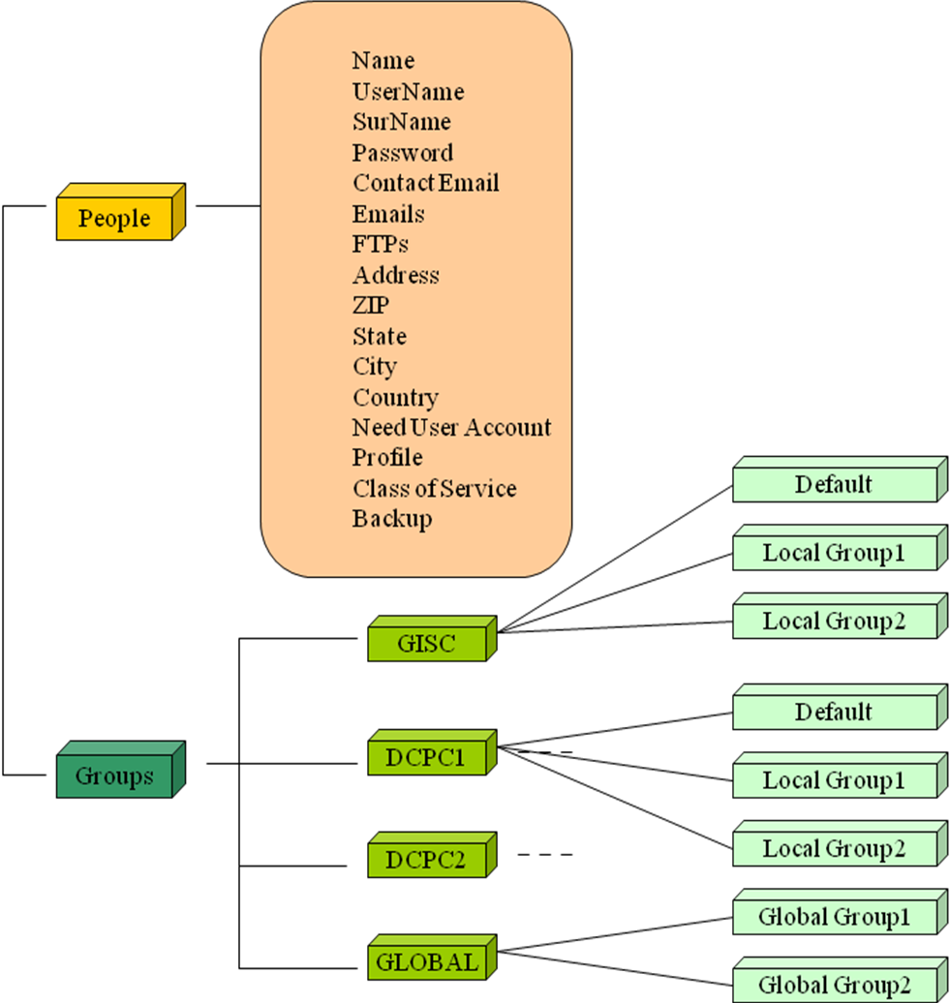

The new nodes are created as the initial one as described in 3.5.

OpenAM will then include Service Providers (i.e. Portals) from the different deployments (3.3.4), along with the definition of Circle of Trusts making trust relationship between the entities.

Maintenance Process
For maintenance or migration purpose, the whole system will need to be restarted.
To avoid losing any data / requests, the following process may be performed:
- On Admin portal: stop all local services (in Backup / Availability of Local System)
This will prevent any users to perform new requests and the system to ingest and process new subscriptions.
- Wait for all JMS queues to go down to 0 (see section 5.6.1)
This will wait for current processing to complete.
- Stop servers (only if necessary) in this order:
  - User Portal(s)
  - Admin Portal
  - Solr
  - Security Service
  - Data Service
  - Postgres
- Perform the maintenance operations
- Start the servers in reverse order (only for servers that have been stopped):
  - Postgres
  - Data Service
  - Security Service
  - Solr
  - Admin Portal
  - User Portal(s)

Pre-Requisites

System Environment
All OpenWIS components are installed on RedHat 5.5.
The following system configuration is required:
- Time set in UTC and synchronized with NTP on an external time server
- English language (required by OpenAM installer)
- Firewall settings to allow communication between components

Hostname Configuration
The first point is to ensure that the hostname is properly set.

Make sure you are logged in as root.
cd /etc/sysconfig
vi network
Look for the HOSTNAME line and replace it with the new hostname you want to use.
HOSTNAME=<HOSTNAME>

Next we will edit the /etc/hosts file and set the new hostname.
vi /etc/hosts

The changes to /etc/hosts and /etc/sysconfig/network are necessary to make your changes persistent (in the event of an unscheduled reboot).
Now we use the hostname program to change the hostname that is currently set.
hostname myhost.domain.com
And run it again without any parameters to see if the hostname has changed.
hostname
Finally we will restart the network to apply the changes we made to /etc/hosts and /etc/sysconfig/network.
service network restart

User
Create a user “openwis”, with the default home directory (/home/openwis).
Copy openwis-dependencies.zip provided in the distribution to /home/openwis.

Java Installation
The following Java version is required: OpenJDK 1.7.0 Update 19 for the Portals and OpenJDK 1.7.0 Update 65 for other installations..

RPM install
Using the “yum” command, install the appropriate version of OpenJDK for the particular component:

For the user and admin portals:
yum -y install java-1.7.0-openjdk-1.7.0.19-2.3.9.1.el6_4

For all other components:
yum -y install java-1.7.0-openjdk-1.7.0.65-2.5.1.2.el6_5.x86_64

Tuning system limits
Maximum Number of Open File Descriptors
OpenWIS system makes intensive use of file access and network connections.
By default, RedHat limits the number of open file descriptor to 1024 by user, which may appear insufficient in case of burst of files or service to process.
Beyond this limit, errors occur in the system such as “Too many open files” or “cannot open connection” to the database, which may cause unexpected and unpredictable problems.
All the components are running as ‘openwis’ user or ‘postgres’ user (database only).
It’s then recommended to increase this limit on all the component hosts.
This is done by configuring the file /etc/security/limits.conf (system needs to be restarted):
openwis - nofile 8192
postgres - nofile 8192

To check this limit has been applied, log in as openwis or postgres user and check:
ulimit –n
Should show: 8192

Security service
The Security Service deployment is composed of:
- OpenDJ (LDAP server)
- OpenAM
- OpenWIS Security Services (User & Group management)
openJDK 7 is required. Note: This has been developed and tested using openJDK7_0.65

OpenDJ
The following sections describe how to install OpenDJ 2.6.0.

/security/openDJ dir0.zip from the association middleware repository:
https://repository-openwis-association.forge.cloudbees.com/private/middleware/OpenDJ-2.6.0.zip

As openwis user, unzip this Archive in /home/openwis directory.
cd
unzip openwis-dependencies/security/openDJ/OpenDJ-2.6.0.zip

Run OpenDJ setup:
cd opendj
./setup for a GUI installation
./setup –-cli for a command line installation

The following steps depend on the way the installation is done: with graphical capabilities or without (command line).

GUI Installation
The splash screen is displayed.

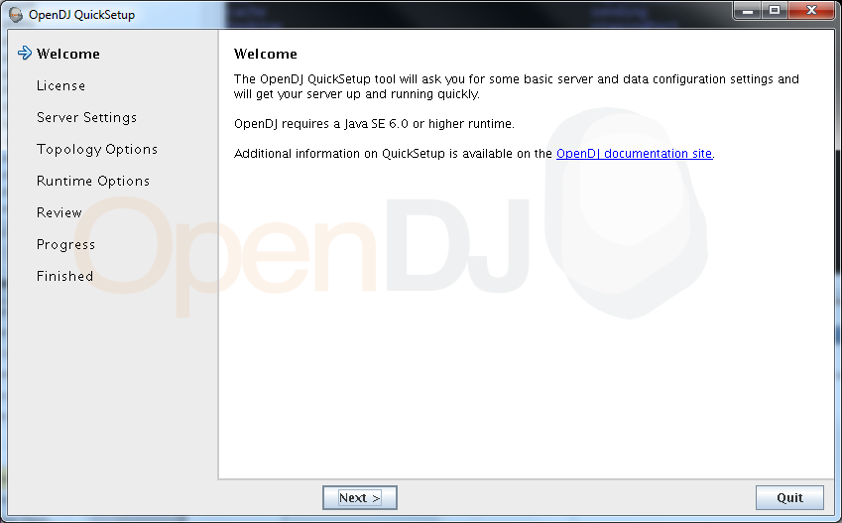
The Welcome page is displayed, click Next

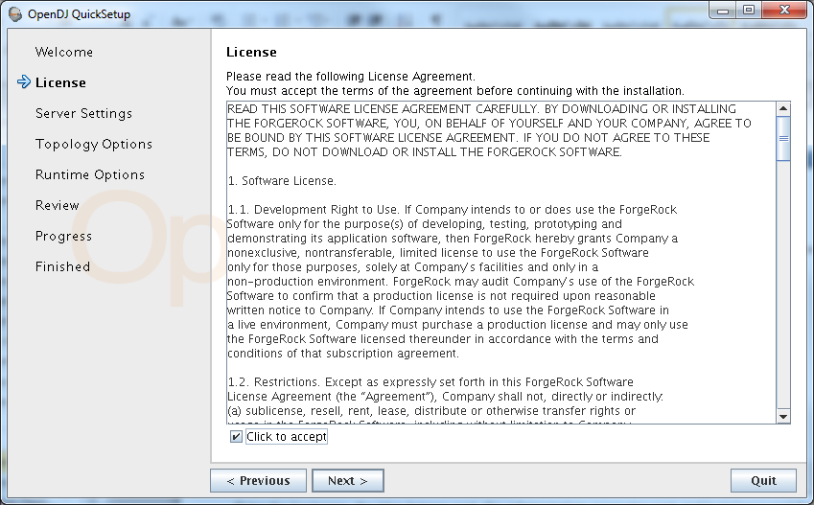
Accept the license, click Next.

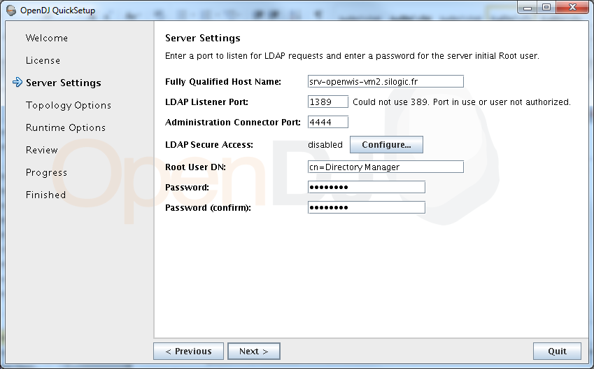
Enter the hostname, the ldap listener port, the administration connector port and login/password for root User DN

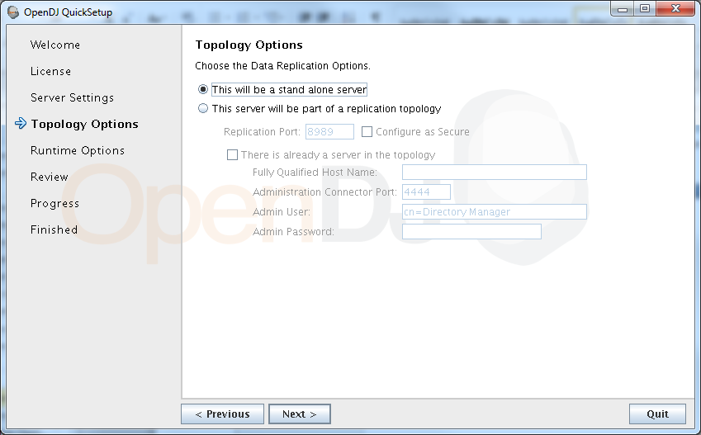

Select Standalone server
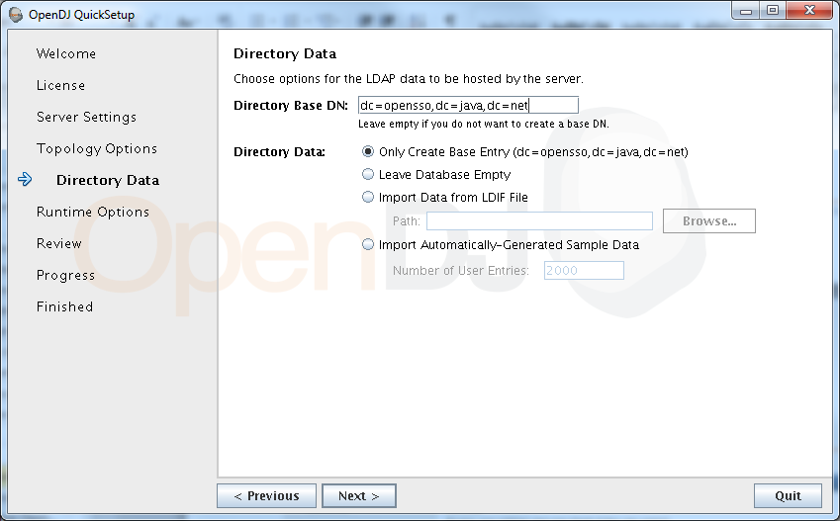
Set Directory Base DN to dc=opensso,dc=java,dc=net

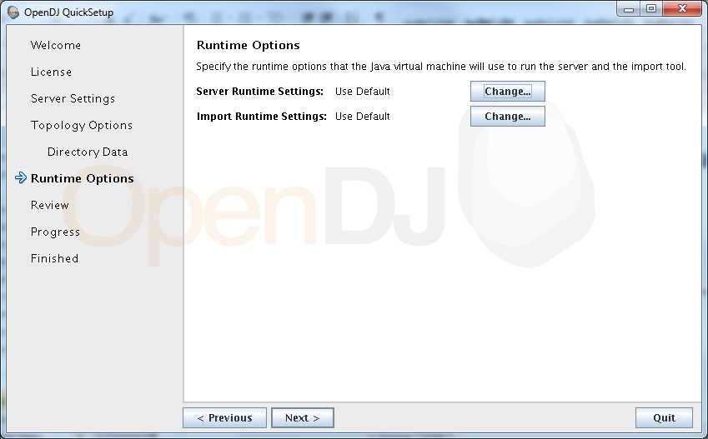
Leave default runtime settings, click Next.

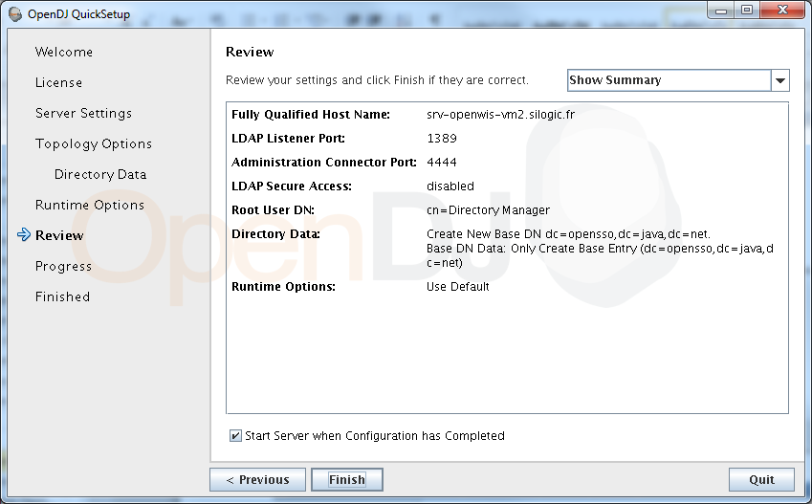
Click on Finish
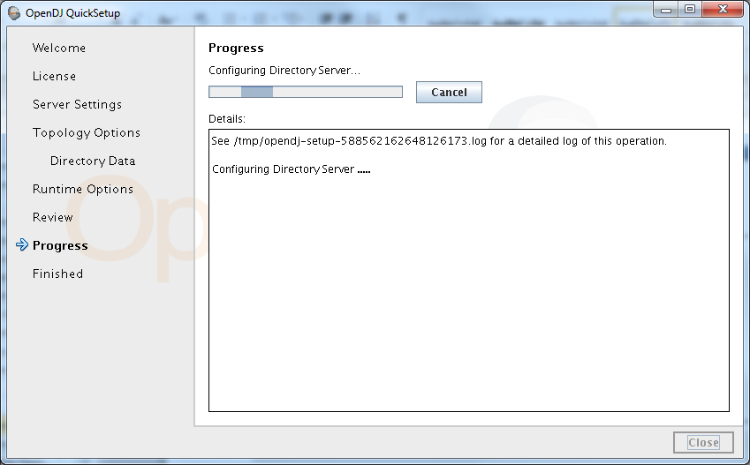
Installation is processing

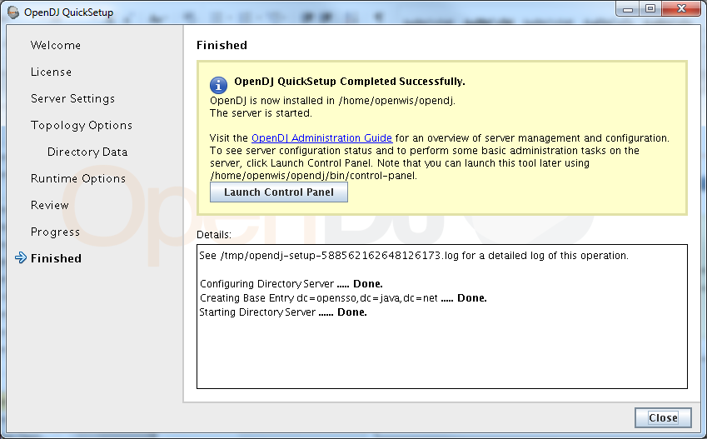
OpenDJ 2.6.0 is now installed and ready for OpenAM installation.

Command Line Installation
…

Please read the License Agreement above.
You must accept the terms of the agreement before continuing with the
installation.
Accept the license (Yes/No) [No]:

Enter: Yes to accept the license

What would you like to use as the initial root user DN for the Directory
Server? [cn=Directory Manager]:
Leave the default value

Please provide the password to use for the initial root user:
Please re-enter the password for confirmation:

Provide the fully-qualified directory server host name that will be used when
generating self-signed certificates for LDAP SSL/StartTLS, the administration
connector, and replication [srv-openwis-vm2.silogic.fr]:
Check fully qualified name of server

On which port would you like the Directory Server to accept connections from
LDAP clients? [1389]:
Leave the default value

On which port would you like the Administration Connector to accept
connections? [4444]:
Leave the default value

Do you want to create base DNs in the server? (yes / no) [yes]:
Leave the default value

Provide the base DN for the directory data:
Enter: dc=opensso,dc=java,dc=net

Options for populating the database:

1) Only create the base entry
2) Leave the database empty
3) Import data from an LDIF file
4) Load automatically-generated sample data

Enter choice [1]: 1

Do you want to enable SSL? (yes / no) [no]:

Do you want to enable Start TLS? (yes / no) [no]:

Do you want to start the server when the configuration is completed? (yes /
no) [yes]:

Setup Summary
=============
LDAP Listener Port: 1389
Administration Connector Port: 4444
LDAP Secure Access: disabled
Root User DN: cn=Directory Manager
Directory Data: Create New Base DN dc=opensso,dc=java,dc=net.
Base DN Data: Only Create Base Entry (dc=opensso,dc=java,dc=net)

Start Server when the configuration is completed

What would you like to do?

1) Set up the server with the parameters above
2) Provide the setup parameters again
3) Print equivalent non-interactive command-line
4) Cancel and exit

Enter choice [1]: 1

Configuring Directory Server ..... Done.
Creating Base Entry dc=opensso,dc=java,dc=net ..... Done.
Starting Directory Server ....... Done.

See /tmp/opends-setup-6028908289502835461.log for a detailed log of this operation.

To see basic server configuration status and configuration you can launch /home/openwis/opendj/bin/status

Start / Stop OpenDS
To start OpenDJ:
cd opendj/bin
./start-ds
To stop OpenDJ:
cd opendj/bin
./stop-ds
To start the OpenDJ console:
cd ~/opendj/bin
./control-panel&
Note: You will need something like XWindows to launch this Control panel GUI

Install OpenDJ as service.
As root:
cp /home/openwis/openwis-dependencies/security/opendj /etc/init.d/
/sbin/chkconfig –-add opendj
/sbin/chkconfig opendj on

Failover considerations
Failover for OpenDJ is configured as an active / active failover.
Two OpenDJ instances run simultaneously and the built-in replication mechanism is activated between each instance.
Install the second instance as the first one (same password for cn=Directory Manager).
To activate the replication between the two instances:
cd ~/opendj/bin (on one of the instance)

./dsreplication enable \
--host1 <HOST1> --port1 4444 --bindDN1 "cn=Directory Manager" \
--bindPassword1 <PASSWD> --replicationPort1 8989 \
--host2 <HOST2> --port2 4444 --bindDN2 "cn=Directory Manager" \
--bindPassword2 <PASSWD> --replicationPort2 8990 \
--adminUID admin --adminPassword <PASSWD> --baseDN "dc=opensso,dc=java,dc=net" -X –n

To initialize the replication:
cd ~/opendj/bin (on the second instance)
./dsreplication
In dsreplication menu:
- Select 3) Initialize Replication on one Server
- Set Source server host name: first instance server and default port
- Trust server certificate: select 3) manually validate
- Set the Global Administrator User ID: ‘admin’
- Set the password for Global Administrator User ID
- Trust server certificate for this session (choice 2)
- Set Destination server host name: second instance server and default port
- Confirm to initialize DN dc=opensso,dc=java,dc=net

Conga configuration
OpenDJ can be managed via Conga.
Create a new script resource “OpenDJ”, referencing the “opendj” script deployed in /etc/init.d.
Create two services from this resource, one for each node.
Associate each node to a failover domain containing only this node.

Import OpenWIS schema
cd /home/openwis/opendj/bin

Import SchemaOpenWIS.ldif
./ldapmodify -h localhost -p 4444 -D "cn=Directory Manager" -w <LDAP_PASSWORD> -a -X --useSSL -f /home/openwis/openwis-dependencies/security/SchemaOpenWIS.ldif

If replication is active the schema must be replicated on each instance (to have all the attributes of OPENWIS)

OpenAM
The following sections describe how to install release 12.0.0
OpenAM is deployed on Tomcat. Report to section 7.1 for details on Tomcat installation.

Configure Tomcat 7 as per usual for your environment:
- Start/Stop scripts to adapt
- Include UTF-8 configuration
- Include VM memory settings
- Tomcat failover consideration:
If failover is configured for component deployed in Tomcat 7 (such as OpenAM), the deployment of the component will be done on two Tomcat instances that run simultaneously.
The Web accessed will be done via a load balancer, such as Apache front-end with mod_proxy module (described in a dedicated section).
To enable session affinity configuration on the load balancer, the Tomcat instances needs to be configured:
vi /home/openwis/apache-tomcat-7.0.59/conf/server.xml
Set the jvmRoute attribute on Engine element:
<Engine name="Catalina" defaultHost="localhost" jvmRoute="node1">

Deploy OpenAM in Tomcat

Download the patched version of OpenAM from the middleware repository:
https://repository-openwis-association.forge.cloudbees.com/private/binaries/openam-patched.war

Deploy it to the Tomcat container:

mkdir /home/openwis/apache-tomcat-7.0.59/webapps/openam
cd /home/openwis/apache-tomcat-7.0.59/webapps/openam
jar xvf dependen/security/oped.war

Note: openam-patched.war is based on OpenAM 12.0.0. It includes a new JSP (spGetToken.jsp), used by OpenWIS portal to retrieve tokens.

OpenAM installation
Pre-requisite:
Tomcat and OpenDJ are started.

Go on OpenAM Installation Page
http://<HOST_NAME>:<PORT>/openam/

WARNING: Don’t use localhost or IP for OpenSSO URL. You have to use the fully qualified Hostname.
WARNING: the System time between each entity must be synchronized with UTC time.
WARNING: When configuring an installation with 2 OpenAM instances (as described in 3.2.5), each OpenAM instance must be installed with its own distinct hostname. The frontend will only be setup during “site configuration”.

Using HTTPS
To setup OpenAM using HTTPS, configure first the Apache front-end (see 7.5.7), and perform the whole installation process via HTTPS instead of HTTP (IDP Discovery included).
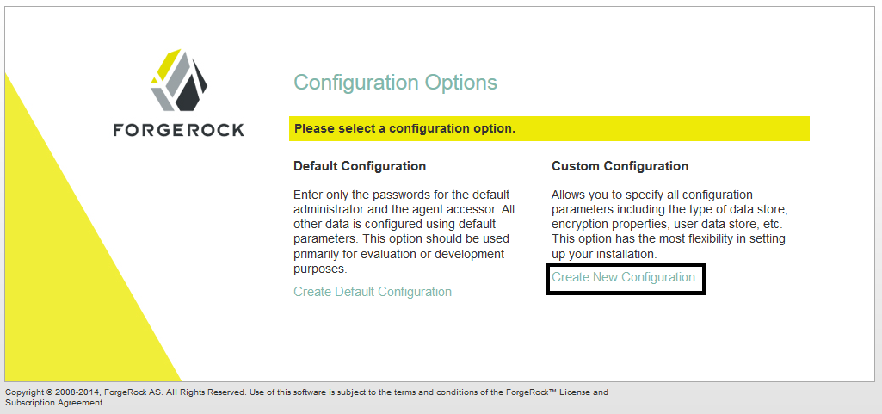
Create a new custom configuration and accept the license.

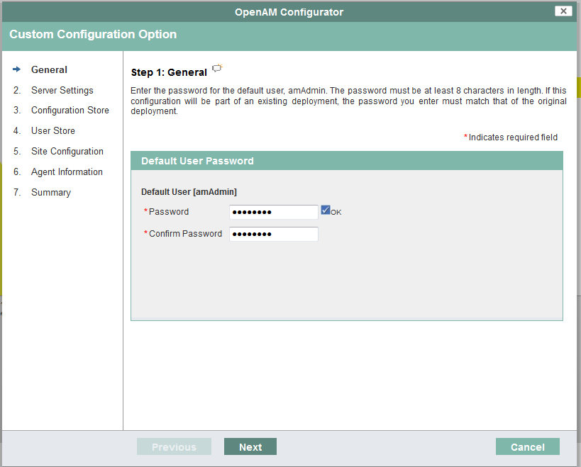
Fill the password of the amAdmin user (OpenAM administrator)
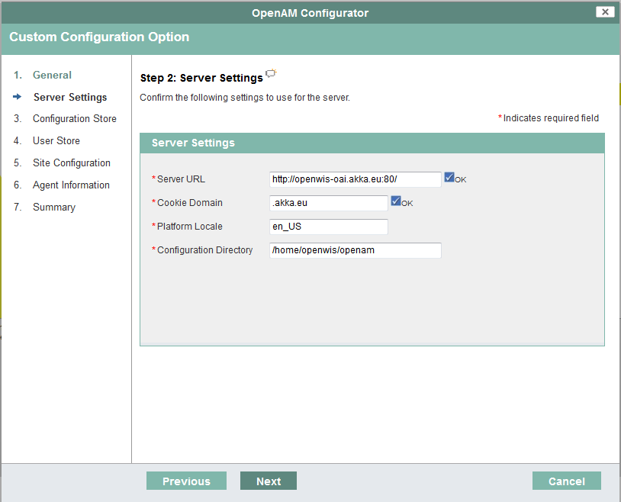
Fill the server URL (fully qualified host name and port) and the cookie domain.

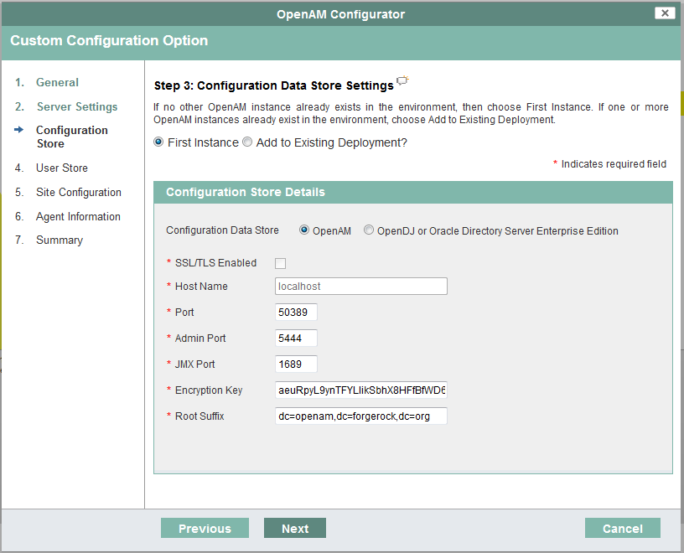
Leave default values.

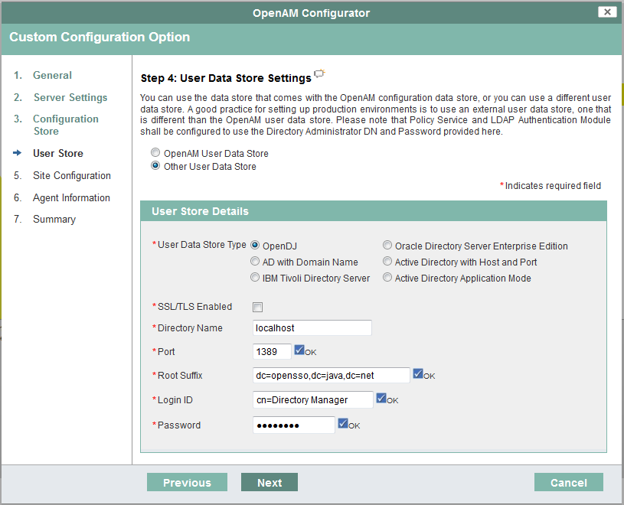
Select OpenDJ as data store type -- WARNING: uncheck OpenDJ and check again OpenDJ (bug OpenAM)
Select the directory host and change the port to 1389.
Fill the password used during the OpenDJ installation.

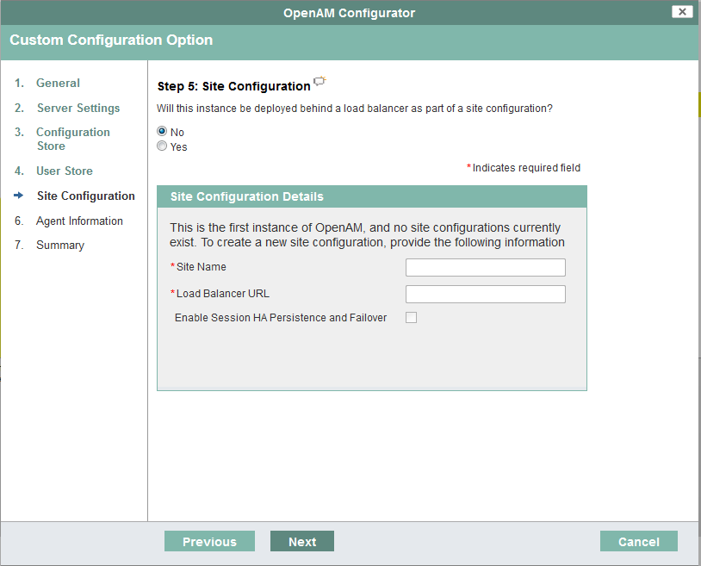
Leave default values.

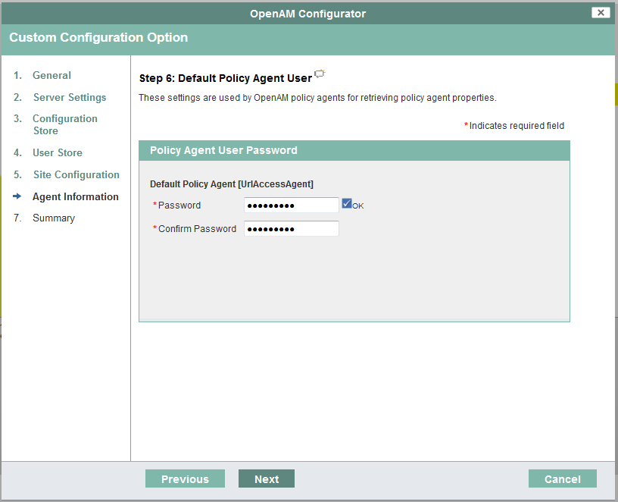
Set the default policy agent (not used in OpenWIS).

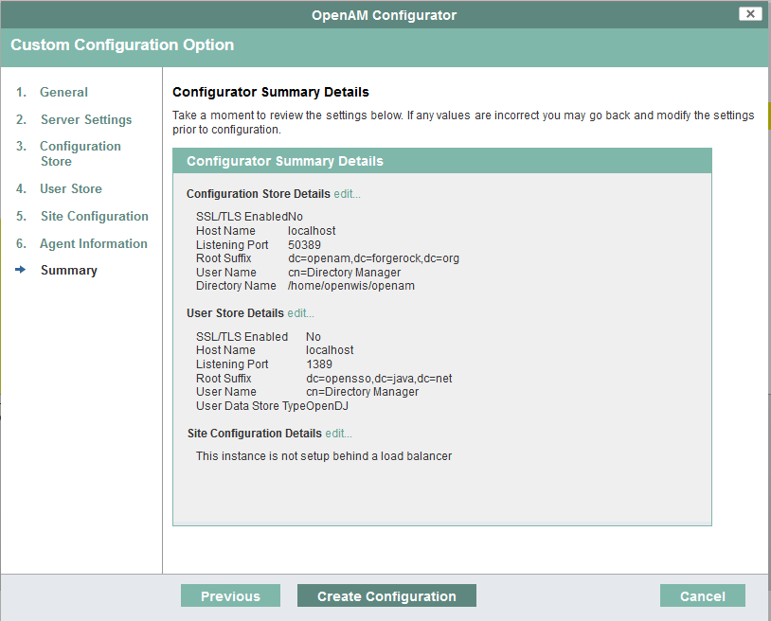

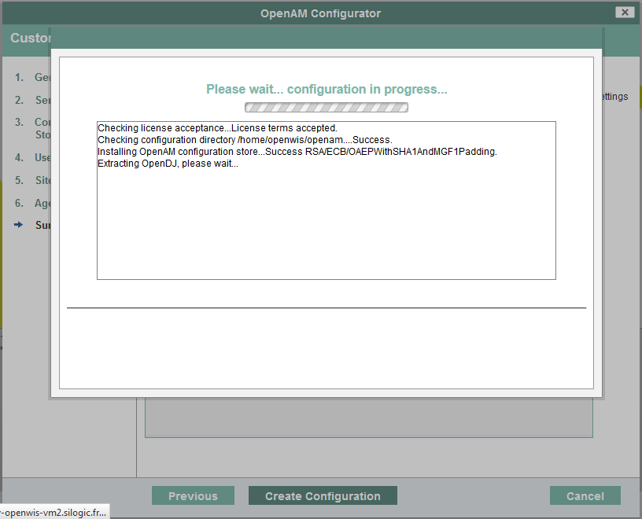

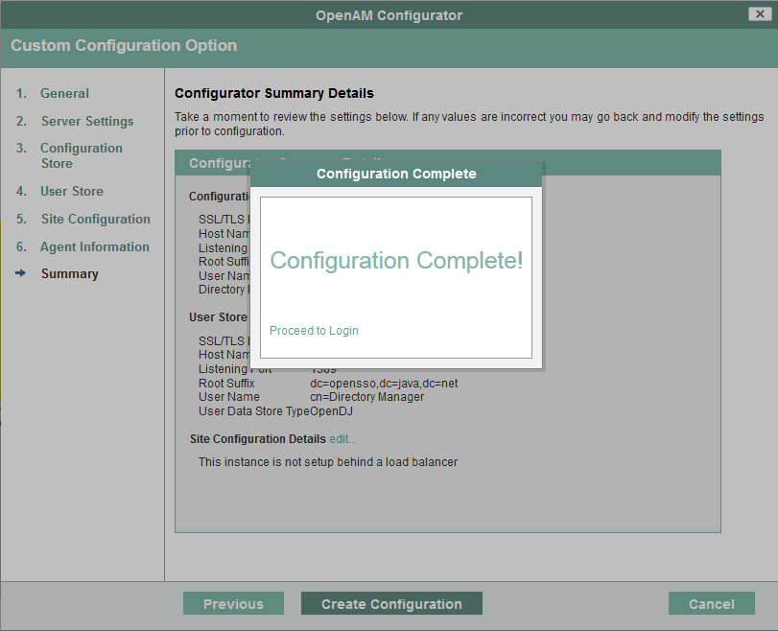

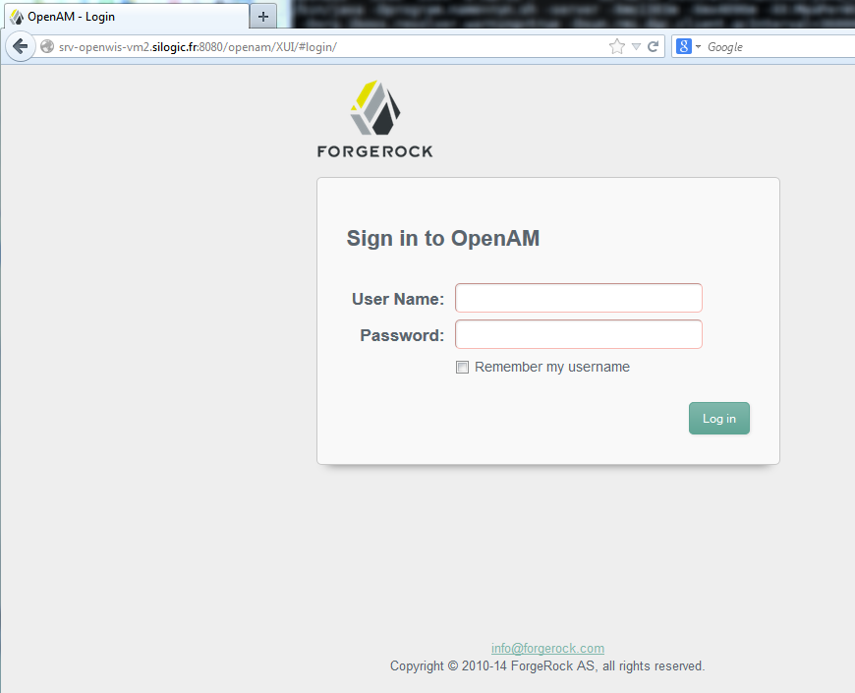
Connect the OpenAM console with amAdmin / password set during the previous step (step 1).
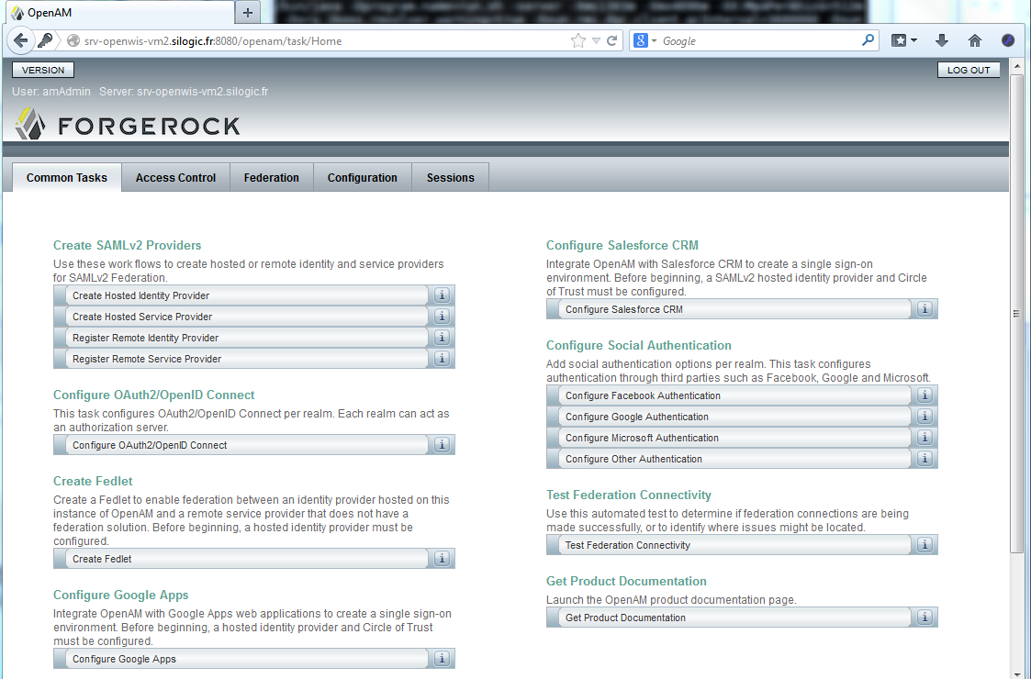

Login page timeout configuration
OpenAM defines a timeout on the Login Page itself (before being logged in) and on timeout, the context is lost by OpenAM preventing the redirect back to the portal after a successful login.
This is related to an OpenAM bug: https://bugster.forgerock.org/jira/browse/OPENAM-93
The bug should be fixed in next versions of OpenAM but the fix does not apply on the current OpenAM version.

As a workaround, the following configuration allows to increase the login page timeout to one week.
On OpenAM console:
- Go to Configuration / Servers and Sites
- Edit server configuration and go to Session Tab
- Click on Inheritance Settings, uncheck Invalidate Session Max Time, then Save
- Set Invalidate Session Max Time to 10081

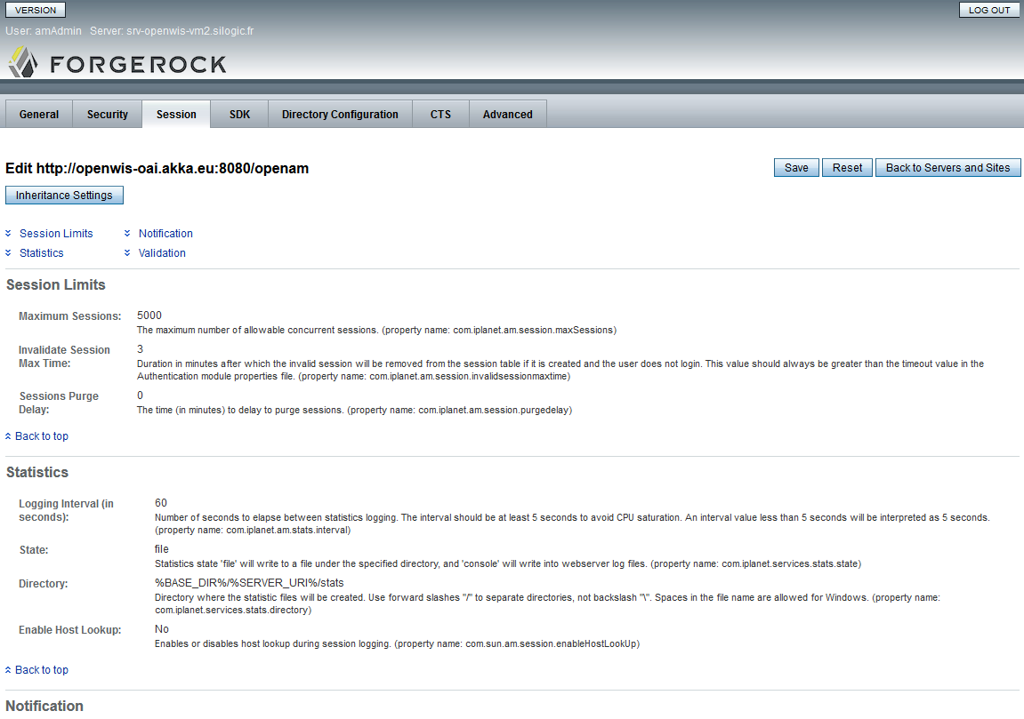

Check OpenAM / OpenDJ connectivity
Start OpenDJ control panel to check OpenAM and OpenDJ are linked.
cd ~/opendj/bin
./control-panel&

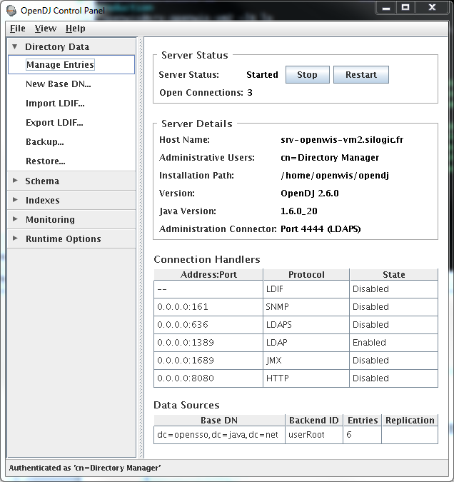

Click on Directory Data / Manage Entries
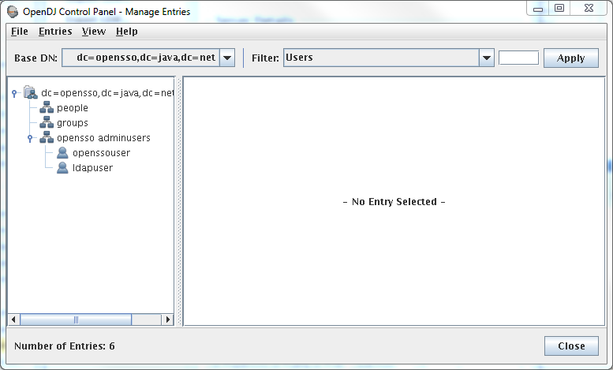
Check the tree structure is equivalent to this screen.

Add OpenWIS User attributes

Open AM Administration Tools Installation

Download the SSO Admin Tools from the middleware repository:
https://repository-openwis-association.forge.cloudbees.com/private/middleware/ssoAdminTools.zip

Unzip the tools and run the setup:
cd /home/openwis
mkdir ssoAdminTools
cd ssoAdminTools
unzip ArchivesOpenWIS/secu
./setup

After license acceptance, you will be prompted for:
# The location of the OpenAM application configuration directory.
Path to config files of OpenSSO server (example: /opensso):/home/openwis/openam
# The location of the OpenAM application debug directory.
Debug Directory:/home/openwis/openam/openam/debug
# The location of the OpenAM application log directory.
Log Directory:/home/openwis/openam/openam/log
The scripts are properly setup under directory: /home/openwis/ssoAdminTools/opensso
Debug directory is /home/openwis/openam/openam/debug.
Log directory is /home/openwis/openam/openam/log.
The version of this tools.zip is: ForgeRock OpenAM Express Build 9(2010-February-07 13:29)
The version of your server instance is: ForgeRock OpenAM Express Build 9(2010-February-07 13:29)

Modify IPlanetAMUserService
cd /home/openwis/ssoAdminTools/opensso/bin
Create a file containing the amAdmin user's password named passwd
echo "amadmin_password" > passwd
Change the mode of passwd. It must be readonly by owner.
chmod 400 passwd

Reload iPlanetAMUserService:
First Delete the service iPlanetAMUserService
./ssoadm delete-svc -u amadmin -f passwd -s iPlanetAMUserService
Then, add it back in
./ssoadm create-svc -u amAdmin -f passwd --xmlfile
/home/openwis/openwis-dependencies/security/amUser.xml

Update the Data Store Configuration
cd /home/openwis/ssoAdminTools/opensso/bin
cp /home/openwis/openwis-dependencies/security/attrs.properties .

Edit attrs.properties and set the values:
- sun-idrepo-ldapv3-config-ldap-server to the LDAP server / port
Example: sun-idrepo-ldapv3-config-ldap-server=localhost:1389
- sun-idrepo-ldapv3-config-authpw to the LDAP password for cn=Directory Manager

Update the data store configuration:
./ssoadm update-datastore -u amadmin -f passwd -e / -m OpenDJ -D attrs.properties

Check OpenAM / Data Store connection
In OpenAM:
Go to Access Control, select the / realm
Go to Data Stores, select OpenDJ

The “LDAP User Attributes section” must contain the OpenWIS attributes (ex OpenWISNeedUserAccount)
The “Attribute Name for Group Membership” must contain isMemberOf

Select “Load schema when saved” and click on Save.
If the message “Profile was updated” appears, the connection is OK.
Otherwise, check the configuration on this page (LDAP host, port and password)

Front-end and Failover considerations
Site Configuration
When OpenAM is accessed via a front-end (for failover or not), a “Site” must be configured to let OpenAM know it is accessed as another host name from outside.
To configure a site, connect as amadmin to OpenAM and go to Configuration / Servers and Sites.
Define a new Site with an arbitrary name and the URL from which the server is accessed from outside.
Edit each server to associate them to the created parent site.
Note: each server must have a distinct hostname/port, different from the frontend.

The Apache front-end configuration is described in a dedicated section.

If the front-end address is not in the same domain as the servers’ one, go to Configuration / System -> Platform and add another cookie domain, based on the external domain.

Failover
For failover, OpenAM is configured as Active/Active.
Two instances of OpenAM run simultaneously and synchronize between each other. Indeed, OpenAM configuration is based on an internal LDAP (internal OpenDS) with replication enabled.
The two instances are accessed via a load balancer with sticky session. The Apache front-end section describes how to configure such a load balancer.

Installation of the second OpenAM instance:
Install the second instance as the first one until the Step 3 of OpenAM setup (Configuration Data Store Settings).
Select Add to Existing Deployment?
Set the server URL of the first instance.

If the configurator manages to contact the given Server URL, everything should be filled automatically.
Proceed to the remaining steps; step 4 is skipped, the configuration of the first instance is applied.
In Step 5 Site Configuration, select No.

Once installed, proceed to login on the second instance and go to Configuration / Servers and Sites.
Edit the second instance and set the parent site to the site configured in the previous section.

The Servers and Sites page should looks like this on both instances:
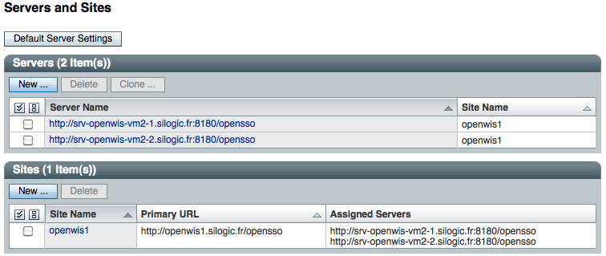

The step Add OpenWIS User attributes is not necessary for the second instance, as the OpenAM configuration is automatically replicated.

The Apache front-end for the failover / load balancing configuration is described in a dedicated section.

In case the OpenDJ is not located on the same host as OpenAM : you need to declare a new data store with the URL of the OpenDJ instance and all the needed information (DN organization, password,…)

OpenWiS Security Configuration
The following sections describe how to define a Circle of Trust via OpenAM, which will include:
- The hosted Identity Provider (IdP): the local IdP provided by this OpenAM
- An optional remote IdP, when IdP federation is required
- The IdP Discovery, allowing to discover an IdP from the portal
- The service providers, which are the OpenWIS portals

Create Hosted Identity Provider
Connect to IDP1 http://<HOST_NAME-1>:<PORT>/opensso
Click on “Common Tasks” tab.

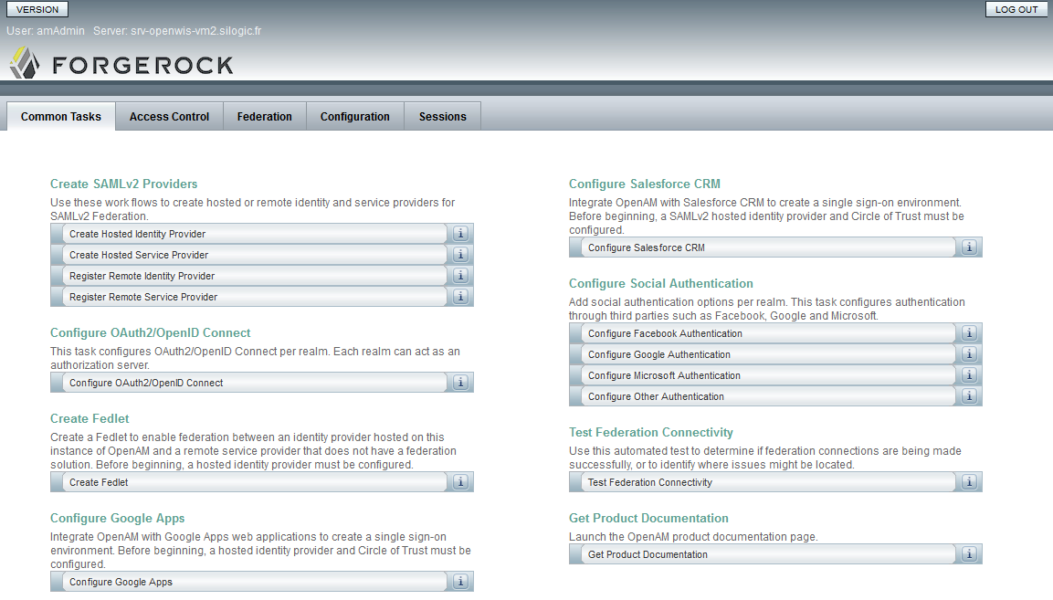
Select Create Hosted Identity Provider

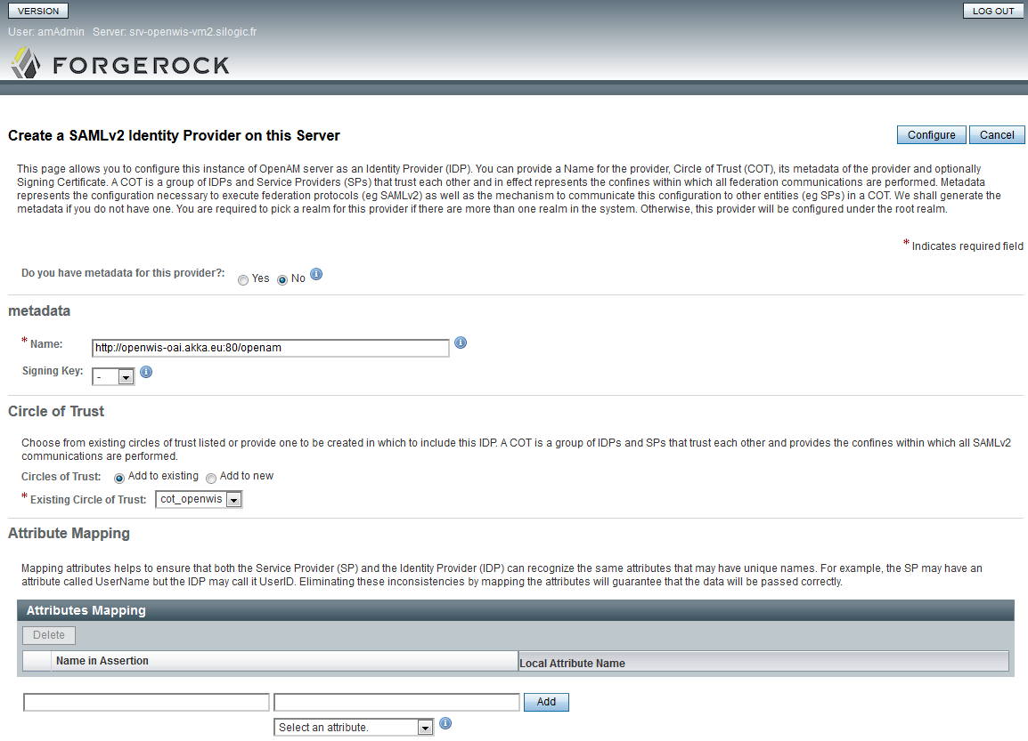
Enter IDP Name: IDP1
Select “test” as Signing key
Enter Circle of Trust name: e.g. “cot_openwis”
Click On Configure

It’s possible to configure the attribute mapper from this page or later as described in section 3.3.5.

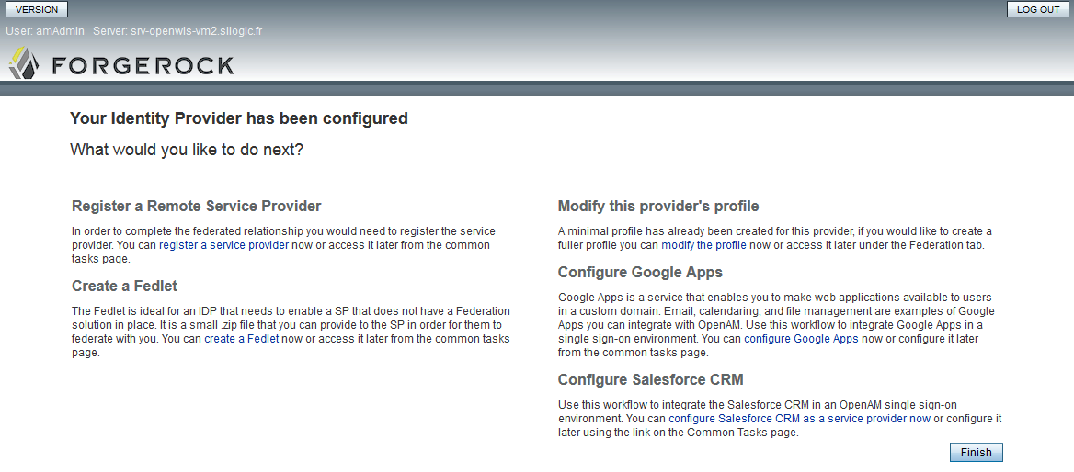
Click on Finish

Front-end / Failover
In case of front-end / failover configuration, it’s necessary to check the service URL automatically configured by OpenAM. In Federation, select the IDP.
Edit Services tab: set all the location with external host names / port.
Edit Advanced tab: set IDP URL with external host names / port.

Register a remote Identity Provider
If needed (federation of Identity providers), it’s possible to register a remote identity provider.
Connect to IDP2: http://<HOST_NAME-2>:<PORT>/opensso
Click on “Common Tasks” tab.

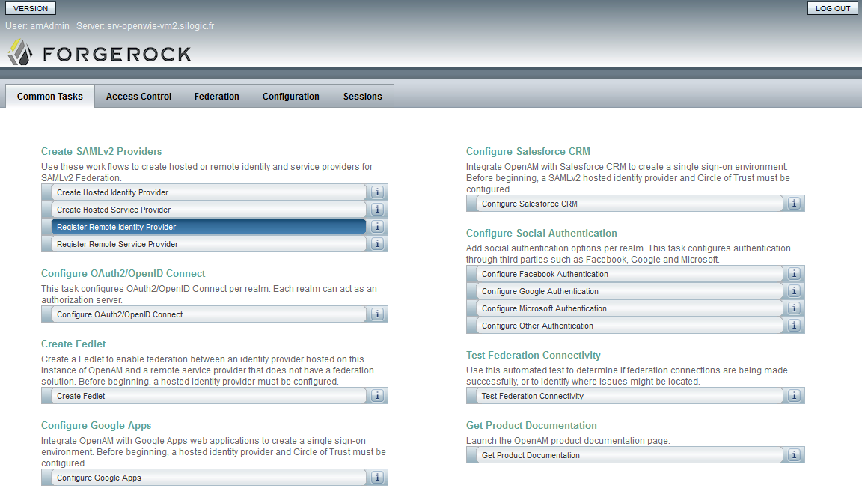
Click on Register Remote Identity Provider

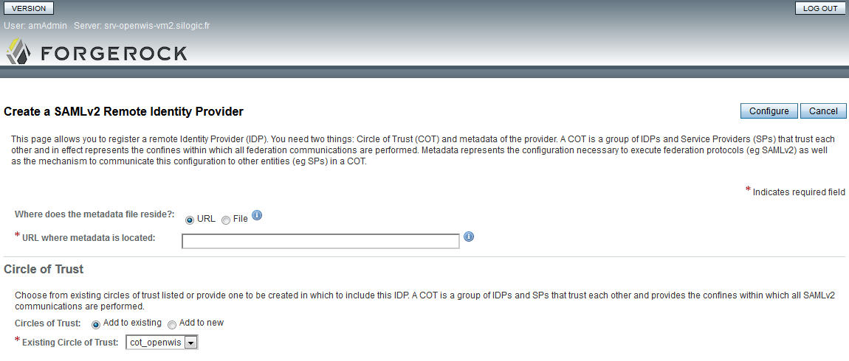
Select URL for locate the metadata file.

Enter the URL:
http://<HOST_NAME-1>:<PORT>/opensso/saml2/jsp/exportmetadata.jsp

Add this circle of trust to the existing previously creating named cot

Click on Configure.
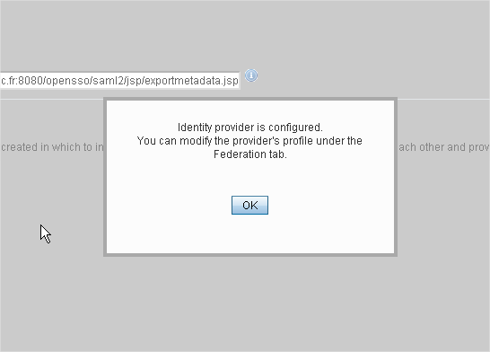

IdpDiscovery
Download idpdiscovery.war from the middleware repository:
https://repository-openwis-association.forge.cloudbees.com/private/middleware/idpdiscovery.war

Deploy idpdiscovery.war into Tomcat, as openwis user:
cd
cp /security/openAM/idpme/openwis/apache-tomcat-7.0.59/webapps

Configuration
Connect to configuring IDP Discovery Service:

http://<IDP_DISCOVERY_HOST_NAME>:<PORT>/idpdiscovery/Configurator.jsp

Set:
- /home/openwis/idpdiscovery as debug directory
- Persistent as cookie type
Click on Configure.


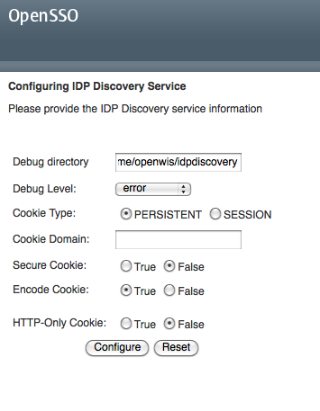
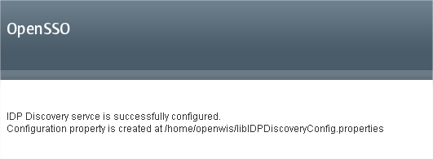

Failover
The IdP Discovery is configured as an active/active failover.
Deploy and configure a second instance of the idpdiscovery war on two JBoss.
Once configured, the instances are accessed via a load balancer as front-end. The Apache front-end section describes how to configure such a load balancer.

IDP Configuration
Connect to each IDP: http://<IDP_HOST-NAME>:<IDP_PORT>/openam

Click on “Federation” tab.
Edit Circle Of trust

SAML2 Writer Service URL:
http://<IDP_DISCOVERY_HOST_NAME>:<PORT>/idpdiscovery/saml2writer

SAML2 Reader Service URL:
http://<IDP_DISCOVERY_HOST_NAME>:<PORT>/idpdiscovery/saml2reader

Note: If an Apache frontend is used to access OpenAM / IdpDiscovery, set the external host name / port configured on the front-end for these services (as described in section 7.5.2).

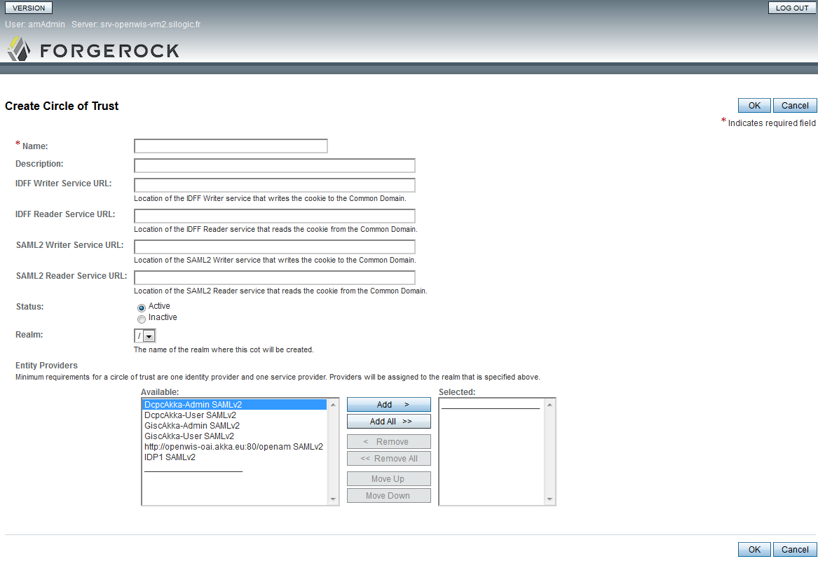

Register a remote Service Provider
Each OpenWIS portal (User or Admin) will be a Service Provider, and will need to be configured before being registered in the Circle of Trust defined previously.
This phase requires the OpenWIS portal to be deployed. Please report to dedicated section of the portal deployment.

Generate Configuration Files on Service Provider
GenerateSPConfFiles is a tool provided to ease the configuration process of a Service Provider. The tool can be downloaded from the middleware repository:
https://repository-openwis-association.forge.cloudbees.com/private/binaries/GenerateSPConfFiles.zip

Unzip GenerateSPConfFiles tool
cd /home/openwis
mkdir GenerateSPConfFiles
cd GenerateSPConfFiles
unzip ArchivesOpenWIS/secuzip

Edit configuration.properties in conf directory:
#Home Directory (Windows : c:/Documents and Settings/<USER-NAME>, Other /home/<USER-NAME>)
directory=/home/openwis

#Circle Of Trust Name
cot-name =cot_openwis → as defined in step 3.3.1

# Service Provider Name
sp-name =GiscA → logical name of the portal: GiscMF, GiscMFAdmin; name to identify the Service Provider in OpenAM

# Service Provider URL (example: http://<HOST-NAME>:<PORT>/<SP-NAME>)
sp-url =http://<external-sp-hostname>/openwis-user-portal (for user portal)

# IDP Discovery URL (example: http://<HOST-NAME>:<PORT>/idpdiscovery)
idp-discovery=http://<external-idpdiscovery-hostname>/idpdiscovery

# IDPs and SPs of the circle of trust. (comma separated)
trusted-providers =IDP1 → at least the IdP, as defined in step 3.3.1

#All IDPS names
idps-names =IDP1 → at least the IdP, as defined in step 3.3.1

#For each IDP name, create a variable <IDP-NAME>.url=http://<HOST-NAME>:<PORT>/opensso
#<IDP-NAME>.url=
IDP1.url=http://<external-idp-hostname>/opensso → at least the IdP, as defined in step 3.3.1

Run GenerateSPConfFiles
cd /home/openwis/GenerateSPConfFiles/apache-ant-1.8.1/bin
chmod a+x *
cd /home/openwis/GenerateSPConfFiles
chmod a+x Generate-SP-Conf-Files.sh apache-ant-1.8.1/bin/ant
./Generate-SP-Conf-Files.sh

The tool generates files in /home/openwis/fedlet, which allows the portals (service provider) to manage SAML2 communications with the other entities.
Multiple IdPs
If several IdPs have been defined, the property idps-names must contain the list of all the IdPs in the order they have been defined. This is important because OpenAM assigns incrementing numbers to the IdPs, and the fedlet need to be aware of these numbers.
After the generation of fedlet files, the fedlet folder will contain two XML files for each IdP (idp<X>.xml / idp<X>-extended.xml). In this case, the login process will display an intermediate step to choose the IdP.
When two distinct hosted IdPs have been defined for deployment reason, this step may not be expected. The non expected IdP files can be removed from the fedlet folder to avoid the intermediate step.

Using HTTPS
When using HTTPS (as described in section 7.5.7) to access OpenAM and/or Portals, the GenerateSPConfFiles tool needs to know the certificate used by Apache.
To import this certificate in the JVM, follow these steps:
- Copy the certificate file in /usr/lib/jvm/jre-1.7.0-openjdk.x86_64/lib/security/
- Import the certificate in cacerts:
cd /usr/lib/jvm/jre-1.7.0-openjdk.x86_64/lib/security/
cp cacerts cacerts.bak # Just in case...
keytool -import -alias ca -file <MY_CERTIFICATE>.crt -keystore cacerts
Keytool request a keystore password which is set by default to: ‘changeit’
Enter keystore password: changeit
Trust this certificate? [no]: yes

The URLs defined in configuration.properties must then contain https instead of http.

Register the remote Service Provider on OpenAM
Connect to OpenAM.
Click on “Common Tasks” tab.

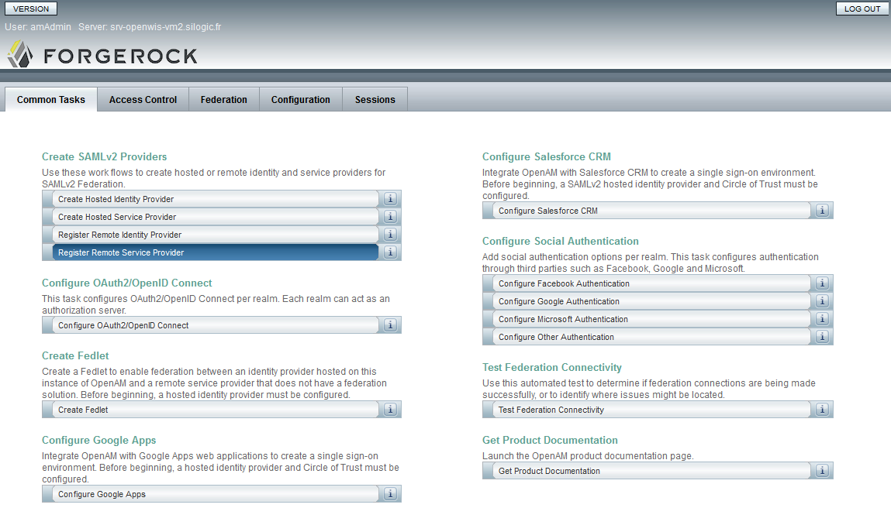
Select “Register Remote Service Provider”.

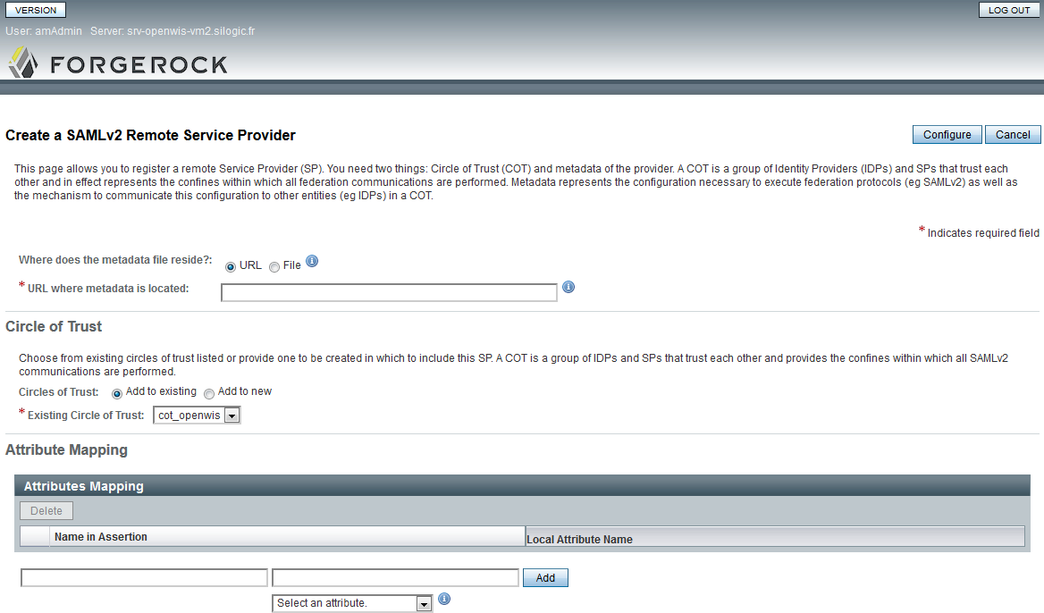
Select URL for locate the metadata file.
URL: http://<SP_HOST_NAME>:<PORT>/<SP_NAME>/saml2/jsp/exportmetadata.jsp

This URL is the URL of the User or Administration portal to register.
For example: http://openwis-oai.akka.eu/openwis-user-portal/saml2/jsp/exportmetadata.jsp
The portal must be running to complete this step.

Add this circle of trust to the existing previously creating.
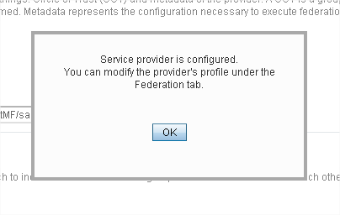
Click on federation tab, you can see the circle of trust with entities (like as bellows)
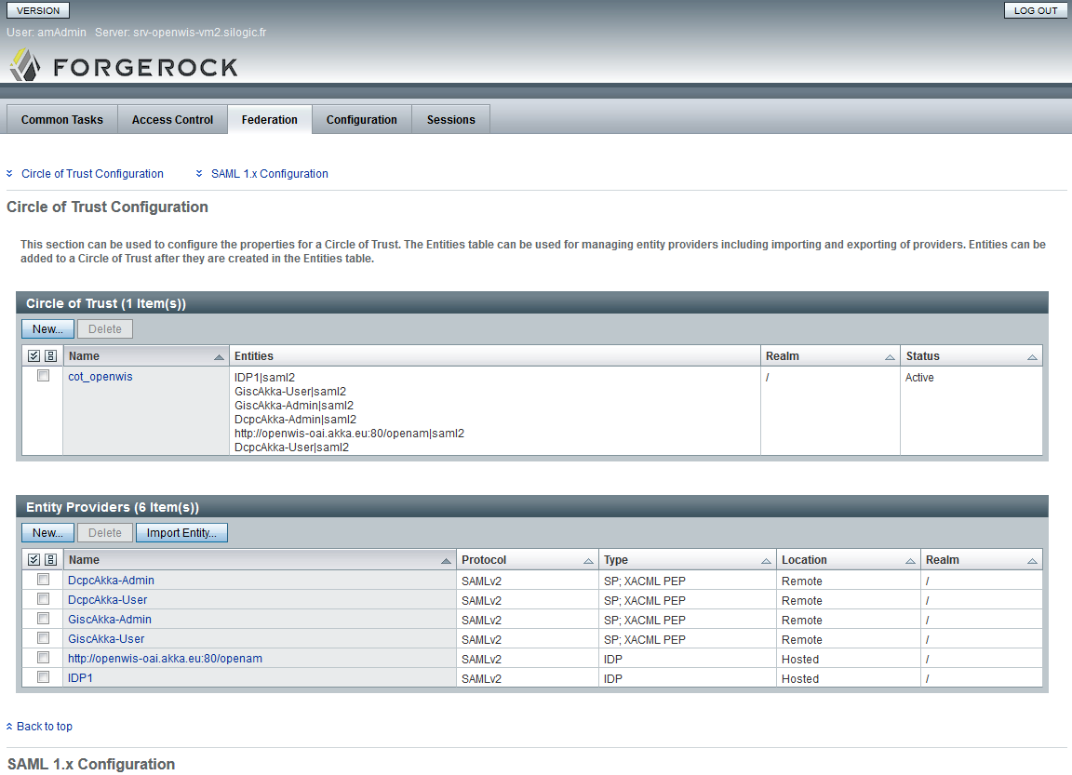

Using HTTPS
When using HTTPS (as described in section 7.5.7) to access Portals, the URL of the portals to register will contain https. To allow OpenAM calling the portals via HTTPS and check the certificate, this certificate needs to be imported in the OpenAM JVM. The steps are described in the previous section (3.3.4.1 / Using HTTPS).

Assertion Processing Attributes
For each Identity Provider in the Federation tab, select “Assertion Processing” tab.
Enter the following attributes to the Attribute Mapper (the attribute names are case sensitive) and save:
OpenWISAddress=OpenWISAddress
OpenWISAddressCity=OpenWISAddressCity
OpenWISAddressZip=OpenWISAddressZip
OpenWISAddressState=OpenWISAddressState
OpenWISAddressCountry=OpenWISAddressCountry
OpenWISClassOfService=OpenWISClassOfService
OpenWISBackUps=OpenWISBackUps
OpenWISProfile=OpenWISProfile
isMemberOf=isMemberOf
OpenWISNeedUserAccount=OpenWISNeedUserAccount
cn=cn
sn=sn
givenname=givenname
mail=mail

Customize OpenAM Login Pages
OpenAM 12.0.0 propose easy mechanism to customize the default login page and other related resource.
Please report to: http://docs.forgerock.org/en/openam/12.0.0/install-guide/index/chap-custom-ui.html
The recommended approach is to customize the page using the new default XUI mechanism.

OpenWiS Security Services (User and Group management)
The WAR of OpenWIS Security Service and the configuration file are deployed in Tomcat that contains OpenAM.
As openwis user:
mkdir /home/openwis/apache-tomcat-7.0.59/webapps/openwis-securityservice
cd /home/openwis/apache-tomcat-7.0.59/webapps/openwis-securityservice
jar xvf openwis-securityservice.war

Edit the configuration file: WEB-INF/classes/openwis-securityservice.properties
The following parameters need to be set:
- ldap_host: set the OpenDJ host
- ldap_port: keep 1389
- ldap_user: keep cn=Directory Manager
- ldap_password: set the LDAP admin password configured during OpenDJ installation
Alternatively this configuration file may be generated by the configuration tool described in section 8.

The following optional parameters may also be set:
- register_users_threshold: number of registered users beyond which an alarm is raised
- global_groups: the default Global groups (comma separated list)
- log.timer.file: the OpenAM file to check for authentication failure
- openwis.management.alertservice.wsdl: the WSDL location of the alert service

The OpenWIS Security Web Services will accessible on URL:
http://<host>:<port>/openwis-securityservice/services/<SERVICE>?wsdl
For example:
http://<host>:8080/openwis-securityservice/services/UserManagementService?wsdl

Front-end and Failover considerations
As for OpenAM, Failover for OpenWIS Web Service is configured as Active/Active.
The WAR of OpenWIS Security Service is deployed on 2 Tomcat instances (which contain the 2 OpenAM instances).
To allow the failover, a load balancing must be configured on Apache frontend as described in section 7.5.3.
The OpenWIS Security Web Services will then be accessible via the frontend.

Initialize Centre in LDAP
When deploying a new Centre, the LDAP must be initialized.
The provided OpenWIS distribution contains a tool called “PopulateLDAP”, which can be used to perform the LDAP initialization when defining a new Centre.
Install PopulateLDAP, for example on the IdP:
mkdir PopulateLDAP
cd PopulateLDAP
unzip PopulateLDAP.zip
chmod a+x populateLDAP.sh

Configure the script populateLDAP to set the webservice location or user and group management.
Run the script:
./populateLDAP.sh

Run Populate LDAP:
- Enter 1, to create a new Centre
- Enter the Centre name (name of the deployment name: e.g. GiscMF)
- Enter the Administrator login, password, email, First name, Last name

This script creates the initial LDAP nodes for a given deployment (groups and organizational units) to allow an OpenWIS authentication.
The created groups need to be known by the portals. An automatic synchronization is done when the portal (user or admin) starts. So remind that the portal may need to be restarted (if already installed and running, as described in section 7.3).

Firewall considerations
OpenDJ uses the following port:
- LDAP Listener Port: 1389
- Administration Connector Port: 4444

OpenDJ must be accessible to:
- OpenAM
- OpenWIS Security Services

If OpenDJ is deployed on the same machine as the Tomcat containing OpenAM and the OpenWIS Security Services, the OpenDJ port don’t need to be opened, as they will be accessed only locally. Otherwise, the two ports need to be opened.

OpenAM uses the following port:
- Default HTTP port for Tomcat: 8080

OpenAM must be accessible to:
- the final user or the Apache front-end
- the OpenWIS portals

OpenWIS Security Services use the following port:
- 8080 WebService

OpenWIS Security Services must be accessible to:
- the OpenWIS portals (on Web port)
- the Data Service (for JNP/RMI port)

Logs and errors
2 categories of logs are available for the Security Service:
- Tomcat logs: in /home/openwis/apache-tomcat-7.0.59/logs/catalina.out; it contains logs generated by Tomcat in general and specifically by the OpenWIS Security Web Services (user and group management)
- OpenAM specific logs: in <openwis_home>/openam/openam/log/; it contains OpenAM specific logs. For details, refer to OpenAM web site:
http://docs.forgerock.org/en/openam/12.0.0/reference/index/chap-log-messages.html

Postgresql

Install Postgresql
PostgreSQL 9 (9.2 is the tested and supported version)) is required along with PostGIS 1.5 and the CIText extension. These are provided as RPM repositories from PostgreSQL. It is recommended to use these repositories to install the database to simplify the process of installing and enabling the extensions required by OpenWIS

Postgres RPM install.
See http://people.planetpostgresql.org/devrim/index.php?/archives/70-How-to-install-PostgreSQL-9.2-on-RHELCentOSScientific-Linux-5-and-6.html
See http://www.postgresonline.com/journal/archives/329-An-almost-idiots-guide-to-install-PostgreSQL-9.3,-PostGIS-2.1-and-pgRouting-with-Yum.html

As root:

Select the appropriate repository for the database version you wish to use and the OS distribution you are installing the database on. The most applicable ones are listed below:
PostgreSQL Version | Operation System | URL
9.2 | RHEL 6.5 (i386) | http://yum.postgresql.org/9.2/redhat/rhel-6.5-i386/pgdg-redhat92-9.2-7.noarch.rpm
9.2 | RHEL 6.5 (x86_64) | http://yum.postgresql.org/9.2/redhat/rhel-6.5-x86_64/pgdg-redhat92-9.2-7.noarch.rpm
URLs of other repositories can be found at: http://yum.postgresql.org/

Install the repository using rpm. Use the URL specific to your OS (e.g. the following is for RHEL 5 x86_64):
rpm -ivh http://yum.postgresql.org/9.2/redhat/rhel-6.5-x86_64/pgdg-redhat92-9.2-7.noarch.rpm

Install the PostgreSQL packages, including the contrib package and the PostGIS package:
yum -y install postgresql92 postgresql92-server postgresql92-libs postgresql92-contrib postgresql92-devel
Using a Custom Data Directory
To use a different directory form the directory used by default:
- Create the /etc/sysconfig/pgsql/postgresql-9.2 in a text editor and add the following:
PGDATA=<data directory>
PGLOG=<data directory>/pgstartup.log

- Make the directory and set the owner to “postgres”:
mkdir -p <data directory>
chown -R postgres: <data directory>

Initializing the Database
The process of initializing the database depends on whether you are using a custom data directory.
- If you are using a custom directory, run the initdb script as the “postgresql” user. Include the full path of the directory as the argument to the “-D” option:
sudo –iu postgres
/usr/pgsql-9.2/bin/initdb -D <data directory>

- If you are using the default data directory, initialize the database as root using the “service” command:
/sbin/service postgresql-9.2 initdb

As the “root” user, start the database:
/sbin/service postgresql-9.2 start

Setting Up The Database

As the “postgres” user:

Create the OpenWIS user. The OpenWIS user should not be a super user and should not need to create any separate databases or user roles. The OpenWIS user, however, may need to create new tables or modify existing tables:
createuser -P openwis
Enter password for new role: <enter password>
Enter it again: <enter password again>
Shall the new role be a superuser? (y/n) n
Shall the new role be allowed to create databases? (y/n) n
Shall the new role be allowed to create more new roles? (y/n) n

Create the OpenWIS database:
createdb -O openwis OpenWIS

Install the PostGIS extension:
# PostGIS RPM install. See http://postgis.net/install/
rpm -ivh http://yum.postgresql.org/9.2/redhat/rhel-6.5-x86_64/geos-3.4.2-1.rhel6.x86_64.rpm

An extra package is required from EPEL Repository
rpm -ivh http://dl.fedoraproject.org/pub/epel/6/x86_64/epel-release-6-8.noarch.rpm

The following packages are then required to support the installation

yum install -y hdf5.x86_64
yum install -y json-c.x86_64
yum install -y proj.x86_64
yum install -y gdal.x86_64

rpm -ivh http://yum.postgresql.org/9.2/redhat/rhel-6.5-x86_64/postgis2_92-2.1.5-2.rhel6.x86_64.rpm http://yum.postgresql.org/9.2/redhat/rhel-6.5-x86_64/postgis2_92-client-2.1.5-2.rhel6.x86_64.rpm
yum install postgis2_92.x86_64 postgis2_92-client.x86_64 postgis2_92-devel.x86_64

Install the following scripts for enabling postgis
psql -d OpenWIS -f /usr/pgsql-9.2/share/contrib/postgis-2.1/postgis.sql
psql -d OpenWIS -f /usr/pgsql-9.2/share/contrib/postgis-2.1/postgis_comments.sql
psql -d OpenWIS -f /usr/pgsql-9.2/share/contrib/postgis-2.1/spatial_ref_sys.sql

Install the following scripts for legacy functions removed from 9.2 which are still required for OpenWIS 3.14
psql -d OpenWIS -f /usr/pgsql-9.2/share/contrib/postgis-2.1/legacy.sql

Install the CIText extension:
psql -d OpenWIS -f /usr/pgsql-9.2/share/contrib/citext.sql

The openwis user will also need to reference three PostGIS tables, which must be granted explicitly. As the “postgis” user, log into the OpenWIS database and execute the following statement:
grant references on geography_columns, geometry_columns, spacial_ref_sys to openwis;

Raising the stack size limit for the PostgreSQL database
With large catalogues and spatial searches, very large SQL queries can be generated on the PostGIS spatial index table. This can cause PostgreSQL to exceed the default process stack size limit. You will know when this happens because a very long SQL query will be output to the SolR log file prefixed with a cryptic message something along the lines of “java.util.NoSuchElementException: Could not acquire feature:org.geotools.data.DataSourceException: Error Performing SQL query: SELECT .........”.
It is therefore necessary to raise the stack size limits of the PostgreSQL database:

Get the permitted stack size of the postgresql user. The result will be return in kilobytes (1,024 bytes).
ulimit -s
10240 # KB = 10 MB

Open “postgresql.conf” in a text editor and search for the key “max_stack_depth”. Uncomment the value if it is commented out, and raise this to about 80% of the value reported by ulimit:
max_stack_depth = 8MB

As root, restart PostgreSQL for the changes to take effect.
/sbin/service postgresql-9.2 restart

If the error still appears these values need to be increased.

Installing The OpenWIS Schema
The OpenWIS distribution comes with two scripts: schema.dll and purge.sql. The schema.dll script is used to create the OpenWIS database tables used by the data services (the tables used by the user portals are created automatically on first start). Both of these scripts are located in “openwis-dependencies.zip”:

As the “openwis” user:

Copy the “schema.dll” file from “openwis-dependencies/database” to the database host and load it into the OpenWIS database:
psql –d OpenWIS –f schema.ddl

Purge script
A purge script purge.sql is provided in openwis-dependencies/database.
It allows to purge the blacklisting entries for users having no activity (request/subscription) since 30 days (default value, can be changed). This is needed in particular because the data service is not strictly related to a local user referential, and can manage requests/subscriptions of user belonging to remote Centre (via Remote Authentication). The user lifecycle (creation/deletion) is then not correlated to the Data Service.
To execute the purge:
psql –d OpenWIS -f purge.sql

Failover considerations
PostgreSQL failover is configured as Active/Passive between two instances. The data are replicated between the two instances (using DRBD for example) or managed on a common secured shared device (SAN for example).
Install the second instance of PostgreSQL as for the first instance.

Configure a replicated or shared device between the two hosts of PostgreSQL. The configuration documentation for DRBD can be found here: http://www.drbd.org/docs/install/.
We assume in the following documentation that the shared or replicated folder is mounted and accessible on /mnt/openwis on both hosts.

Conga configuration
Conga comes with a script for postgres8 which does not work properly. A new script is provided in the ArchivesOpenWIS, which should replace the default one.
As root:
cp ArchivesOpenWIS/postgresql/postgres-8.sh /usr/share/cluster/

In Conga:
- Configure a new PostgreSQL 9.2 resource
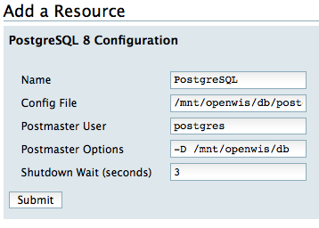
The config file is /mnt/openwis/db/postgresql.conf

- Configure a new IP address resource
Set a virtual IP address on which the postgres process will listen.
Select Monitor link.

- Configure a new File System resource

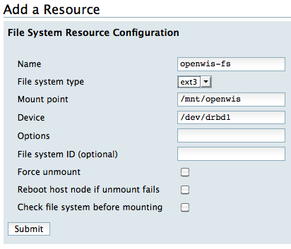

If DRBD is used, configure a script resource to start/stop DRBD on the correct DRBD resource. On DRBD install, the script /usr/share/cluster/drbd.sh is created. It can be copied as drbd-r0.sh for example and modified to set OCF_RESKEY_resource=r0 at the beginning of the script.

- Configure a new Service “postgres”
  - Add PostgreSQL script
  - Add the virtual IP address as child
  - Add File System as child (or Add the DRBD script if needed and add the File System resource as child of DRBD script
  - To enable automatic failover mechanism, select a failover domain containing the two nodes and relocate as recovery policy
Access control:
The following components will access the database:
- User portal
- Admin portal
- Data Service and Management Service
- Solr

As the “postgresql” user:

Edit the pg_hba.conf to allow access to these components.
Edit the postgresql.conf and set listen_addresses to the host IP address (or ‘*’) if the database needs to be accessible from outside this host.
Note: the data directory needs to have an access mode of 700 and to belong to postgres user.

Firewall considerations
PostgreSQL uses the following port: 5432
PostgreSQL must be accessible to:
- the Data Service
- the OpenWIS portals
- Solr

Data AND MANAGEMENT ServiceS

Installing The Data AND MANAGEMENT Services
The Data Service and Management Services run in the community edition of JBoss AS 7.1.1.

Preparing The Environment

Ensure that you have installed JDK 1.7 (OpenJDK)

As the openwis user:

Download the latest version of JBoss AS 7.1.1 from the JBoss website: http://download.jboss.org/jbossas/7.1/jboss-as-7.1.1.Final/jboss-as-7.1.1.Final.zip

Unzip it in the openwis home directory:
unzip jboss-as-7.1.1.Final.zip

Open ~/.bashrc in a text editor and add the following lines and reload .bashrc
export JBOSS_HOME=”$HOME/jboss-as-7.1.1.Final”

The time-zone used by the JVM will need to be explicitly set to UTC. Open $JBOSS_HOME/bin/standalone.conf in a text editor and add the following line:
JAVA_OPTS=”$JAVA_OPTS -Duser.timezone=UTC”

JBoss is configured to use a maximum of 512 Mbytes of heap space by default. If the host allows more memory allocation, it is recommended to increase this maximum value. In $JBOSS_HOME/bin/standalone.conf:
JAVA_OPTS="-Xms256m –Xmx512m -XX:MaxPermSize=256m”
The following parameters may be adjusted:
- -Xmx represents the maximum of memory usage (‘m’ means Mbytes)

The server logs will be written to $JBOSS_HOME/standalone/log. To have the logs written to another location, you can replace the empty log directory with a symbolic link to the desired log directory:
ln –s $JBOSS_HOME/standalone/log <target log dir>

Unzip openwis-dataservice-config-files.zip in the openwis home directory. Copy the start and stop scripts into the home directory of openwis.
unzip openwis-dataservice-config-files.zip
cp openwis-dataservice-config/*.sh ~/.

The following configuration values for JBoss are configured as part of the start script and can be changed if necessary:
- bindingAddress: The address JBoss will be bound to. Default = “0.0.0.0”
- multicastAddress: The multicast address used for communication between cluster members. All cluster members must have the same multicast address. Default = “239.255.100.100”
In order to change these properties, open start_openwis_jboss.sh in a text editor and change the appropriate configuration value.

MSS/FSS File Harness and Cache configuration
The MSS/FSS file harness as well as the Cache need some created folders.
The following sections give an example of structure that can be customized if needed (openwis-dataservice-jndi-service.xml configuration file needs to be in line with the following structure).

As root:
mkdir /var/opt/openwis
chown openwis:openwis /var/opt/openwis

As openwis:
mkdir /var/opt/openwis/harness
mkdir /var/opt/openwis/harness/incoming
mkdir /var/opt/openwis/harness/ingesting
mkdir /var/opt/openwis/harness/ingesting/fromReplication
mkdir /var/opt/openwis/harness/outgoing
mkdir /var/opt/openwis/harness/working
mkdir /var/opt/openwis/harness/working/fromReplication
mkdir /var/opt/openwis/cache
mkdir /var/opt/openwis/stagingPost
mkdir /var/opt/openwis/temp
mkdir /var/opt/openwis/replication
mkdir /var/opt/openwis/replication/sending
mkdir /var/opt/openwis/replication/sending/local
mkdir /var/opt/openwis/replication/sending/destinations
mkdir /var/opt/openwis/replication/receiving
mkdir /var/opt/openwis/status

These folders correspond to:
- Incoming: folder on which incoming GTS files are dropped and consumed by OpenWIS dispatch process
- Ingesting: folder containing files to ingest (after dispatch)
- Outgoing: folder on which OpenWIS feeds files to the GTS
- Working: internal working folder
- Cache: the cache root directory
- StagingPost : the staging post root directory
- Temp : the directory for temporarily stored files
- Replication: the directory for the replication folders, with the following sub-structure
  - sending / local: contains a buffer of 24 hours data received from GTS and that needs to be sent to replication destination
  - sending / destinations / <DESTINATION_NAME>: contains links to sending/local data that are currently sent to the given destination
  - receiving / <SOURCE_NAME>: contains files received from the replication from the given source
- Status: the directory containing status files (status of each services)

Depending on the deployment, all these directories, and in particular the Cache and Staging Post directories, may correspond to mounted folders, targeting network shared locations (NFS, Samba…).

Configuring the Data Services
The JBoss environment will need to be configured for the data and management services, and the services will need to be configured themselves. This can either be performed using the assisted configuration procedure, which includes generating the necessary configuration and initialization files using a Python script, or by using the manual configuration procedure.

Assisted Configuration
This procedure requires Python 2.6+ to be installed on the data service host.

As openwis:

Run the data-service-setup.py script.
cd openwis-dataservice-config
./data-service-setup.py

This script will prompt you for the following information:
- Location of the data and configuration directories
- Location of the PostgreSQL drivers
- Database connection and login details
After successful execution of the script, it will generate the following three files in the configuration directory.
- openwis-dataservice.properties: Configuration of the data and management service
- localdatasourceservice.properties: Configuration of the local data source
- setup-openwis.cli: JBoss CLI batch file which will configure the environment

Start JBoss
cd ~
./start_openwis_jboss.sh

Load the generated CLI batch file
$JBOSS_HOME/bin/jboss-cli.sh --file=conf/setup-openwis.cli

If the message “Failed to execute batch” appears, check server.log for any errors. If there are no errors, this message can be disregarded.

Deploy the management and data services
$JBOSS_HOME/bin/jboss-cli.sh -c --command=”deploy <openwis-management-service.ear>”
$JBOSS_HOME/bin/jboss-cli.sh –c --command=”deploy <openwis-dataservice.ear>”

Further configuration of the data services may be necessary for a fully functional system. Specifically, it might be necessary to configure the following (these are the properties highlighted in bold in Table 1: Data Service configuration properties):
- dataService.baseLocation: Base data directory.
- stagingPost.url: URL to the staging post
- cache.dissemination.disseminationHarness.*.url: URL to the dissemination harness
- mail.from: Email sender for mail deliveries
- mail.smtp.host: SMTP host for mail deliveries

Manual Configuration

As the openwis user:

Create a “conf” directory in the home directory of openwis and copy the template configuration files:
mkdir ~/conf
cp openwis-dataservice-config/config/*.properties ~/conf/.

Make appropriate changes to the configuration files located in ~/conf. The following files can be configured:

LocalDataSource configuration - localdatasourceservice.properties:
For each available local data sources, set the following key/values:
- Identification of the local data source:
  - Key: logical name of the data source
  - Value: URL of the WSDL corresponding to the Local Data Source Web Service
- Polling mechanism (to detect availability of new products)
  - Key: <logical name of the data source>.polling
  - Value: true or false to enable/disable the polling of the data source

DataService configuration - openwis-dataservice.properties:
This configuration section contains a lot of parameters that can be configured. Placeholders surrounded with “@” will need to be replaced.
Most of typical deployments will have to configure only the basic ones, shown in the following table. The parameters marked in bold must be set for a new installation:
Data Service Directories Locations
dataService.baseLocation | Base location of the data services data directory (e.g. “/var/opt/openwis”).
cache.dir.stagingPost | The path to the staging post directory. (same as ‘staging.post.uri’ value)
cache.dir.temp | The path to the temporary directory
cache.dir.cache | The path to the cache root directory
cache.dir.harness.incoming | The path to the incoming directory (folder in which GTS flow is dropped)
cache.dir.harness.ingesting | The path to the folder containing files to ingest (after dispatch)
cache.dir.harness.working | The path to the working directory (batch files being ingested are split in this folder, after ingesting)
cache.dir.harness.outgoing | The path to the outgoing directory for feeding
dataservice.service.status.folder | The path to the folder containing status files for each sub-services.
cache.replication.config.folder | The path to the folder containing replication sub-folders (sending/receiving)
FTP Replication Settings
cache.replication.config.fromReplication.folder | Name of sub-folder of ingesting and working folders where files are dropped when received from replication
Cache Feed/Ingest Settings
cache.config.numberOfChecksumBytes | The number of bytes of a file on which the checksum will be calculated
cache.config.location.sendingCentre | The 4-letter-location-code of the sending (the local) centre (used as a prefix of outgoing WMO FTP files).
Dissemination Configuration
staging.post.uri | The path to the staging post directory.
cache.dissemination.stagingPost.purgeTime | [minutes] The entries in the “StagingPostEntry” database table and the files on the staging post, referenced in those entries, which are older than this value will be deleted.
cache.config.stagingPostMaximumSize | The maximum number of bytes in the staging post.
cache.config.cacheMaximumSize | The maximum number of bytes in the cache.
cache.dissemination.disseminationHarness.public.url | The URL of the public dissemination harness. Set the empty if there is no public dissemination harness available.
cache.dissemination.disseminationHarness.rmdcn.url | The URL of the RMDCN dissemination harness. Set to empty if there is no RMDCN dissemination harness available.
cache.dissemination.threshold.mail | The maximum number of bytes to send via email
cache.dissemination.threshold.ftp | The maximum number of bytes to send via ftp
mail.from | Sender of the blacklisting emailing
mail.smtp.host | SMTP Host for the blacklisting emailing
mail.smtp.port | SMTP Port for the blacklisting emailing
blacklist.default.nb.warn | Default blacklisting warning threshold regarding the number of files
blacklist.default.nb.blacklist | Default blacklisting threshold regarding the number of files
blacklist.default.vol.warn | Default blacklisting warning threshold regarding the volume
blacklist.default.vol.blacklist | Default blacklisting threshold for the volume
Management WebService URLs
openwis.management.alertservice.wsdl | The WSDL URL of the alert service. (update Host/Port with the location of the Management service)
openwis.management.controlservice.wsdl | The WSDL URL of the control service. (update Host/Port with the location of the Management service)
openwis.management.controlservice.defaultFeedingFilterLocation | The full path and name (e.g. ‘defaultFeedingFilters.config’) of a file containing the default feeding filters. The content of this file must be one regular expression per line, each line thus defines a filter.
openwis.management.disseminateddatastatistics.wsdl | The WSDL URL of the disseminated data statistics. (update Host/Port with the location of the Management service)
openwis.management.exchangeddatastatistics.wsdl | The WSDL URL of the exchanged data statistics. (update Host/Port with the location of the Management service)
openwis.management.replicateddatastatistics.wsdl | The WSDL URL of the replicated data statistics. (update Host/Port with the location of the Management service)
openwis.management.ingesteddatastatistics.wsdl | The WSDL URL of the ingested data statistics. (update Host/Port with the location of the Management service)
Other Settings
cache.cacheManager.housekeepingTimer.expirationWindow | [days] The number of days the cache content will be valid before it gets removed
cache.cacheManager.purgingTimer.expirationWindow | [ms] The number of milliseconds a file will be kept in temporary directory.
Table 1: Data Service configuration properties
Advanced parameters are described in appendix (see section 11.1); they should not to be modified on a typical deployment.

Configuring JBoss

Services provided by JBoss to the Data and Management Services will need to be provisioned and configured before the EAR files are deployed. This is done through the JBoss CLI batch file, which will be loaded while JBoss is running. The batch file will configure the following services:
- The socket group, which will change the HTTP port to “8180”.
- The application logging.
- The data source which the data/management services will use to access the database.
- The messaging queues.

As the openwis user:

Start JBoss AS 7.1 using the start_openwis_jboss.sh script:
cd ~
./start_openwis_jboss.sh

Using the JBoss CLI, deploy the PostgreSQL 9.2 JDBC library:

$JBOSS_HOME/bin/jboss-cli.sh -c --command=”deploy <path to postgresql-9.2-1003-jdbc4.jar>”

Open openwis-dataservice-config/config/setup-openwis.cli in a text editor and replace the following placeholders:
Placeholder | Description | Typical Value
@openwis.db.host@ | Database hostname
@openwis.db.port@ | Database port | 5432
@openwis.db.name@ | OpenWIS database name | OpenWIS
@openwis.db.username@ | Username of the OpenWIS database user | openwis
@openwis.db.password@ | Password of the OpenWIS database user
@postgresql.driver.name@ | Basename of the driver deployed in step 2 | postgresql-9.2-1003-jdbc4.jar
@openwis.config.dir@ | Directory containing openwis-dataservice.properties and localdatasource.properties, resolved from the home directory | conf

Load the batch file using the JBoss CLI:
$JBOSS_HOME/bin/jboss-cli.sh --file=setup-openwis.cli

Deploy the application EAR files using the CLI:
$JBOSS_HOME/bin/jboss-cli.sh -c --command=”deploy <openwis-management-services.ear>”
$JBOSS_HOME/bin/jboss-cli.sh -c --command=”deploy <openwis-dataservice.ear>”

Logs configuration:
Logging is configured using JBoss AS 7.1.1 CLI tool. By default, the server is configured to write the following logs to the <JBOSS_HOME>/standalone/logs folder:
- server.log: default logs of JBoss containing all the logs
- collection.log: logs related to collection
- request.log: logs related to request
- alerts.log: logs all alarms (raised by management service)
The logs rolled every day and are not purged by JBoss (see CRON purge in later section)

Cache Replication

Replication mechanism
The following picture shows the replication mechanism:
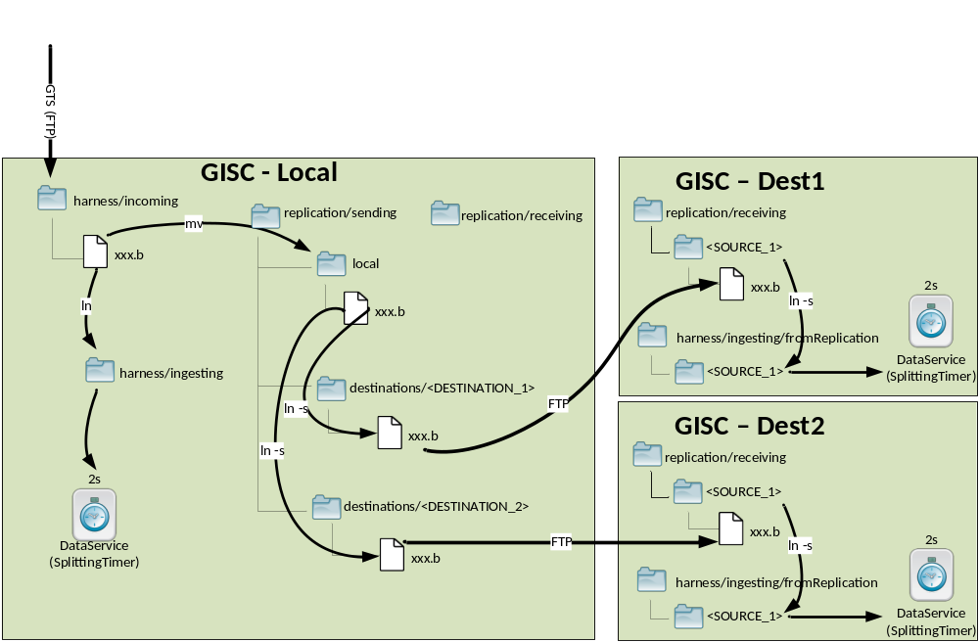
The replication consists in the following steps:
- GTS flow is dropped in harness/incoming folder
- Dispatch process: monitors harness/incoming and for each incoming file
  - create a hard link on this file in harness/ingesting; the file will then be ingested by the local Data Service
  - move the file in replication/sending/local
  - create a symbolic link in all replication/destinations sub-folders
- FtpReplicator: monitors each destination sub-folders and for each incoming file (actually link):
  - send it to the configured host associated to the destination by FTP
  - remove the link from destination sub-folder if the upload succeeded
- On receiver side:
  - the file is received in a sub-folder of replication/receiving
  - the sub-folder can be a simple link in harness/ingesting/fromReplication folder, which is monitored by the Data Service for ingestion (and identified as a flow coming from the replication); in this case the received file is consumed by the Data Service
An alternative to this step would be to dispatch the received file (thanks to a dedicated script equivalent to the Dispatch process – not provided) to be able to send the file in the replication process (the receiver acts as a relay for another destination); in this case the dispatch process, follow the steps:
  - create a hard link on the file in harness/ingesting/fromReplication; the file will then be ingested by the local Data Service
  - move the file in replication/sending/local
  - create a symbolic link in all (or only a sub-set) replication/destinations sub-folders, which will then get back to step 3

The folder replication/sending/local represents a buffer of 24 hours of files received from the GTS that may be used to resend files in case of FTP upload failure. (Enough disk space needs to be provisioned)
The replication folders will be purged thanks to dedicated CRON statements (described in section 5.3).

Deploy the OpenWIS Dispatcher
The Dispatcher is a simple script. It is based on inotify, a standard Linux sub-system that acts to extend filesystems to notice changes to the filesystem, and report those changes to application.
Inotify monitors the harness/incoming folder and triggers the steps described in step 2 of the previous section.
Important deployment note: when the Data Service and the Replication are deployed on 2 separated hosts, sharing harness and replication folders via NFS:
- deploy the Dispatcher script on the Replication host (optimize hard link and move steps)
- the GTS flow needs to be dropped in harness/incoming via the Replication host (otherwise inotify won’t be able to detect any new incoming files)

The Dispatcher requires inotify tools.
Install it as root with the following command:

yum -y install inotify-tools

The dispatcher scripts are located in “openwis-dataservice-config-files.zip”.
Deploy the dispatcher script (start and stop), as openwis:
cp /home/openwis/openwis-dataservice-config/dispatch/*_openwis_dispatch.sh /home/openwis
chmod a+x /home/openwis/*_openwis_dispatch.sh
The Dispatch script start_openwis_dispatch.sh may be edited to configure (in particular):
- rootFolder: root folder of all data service folders (default /var/opt/openwis)
- logsEnabled: set to true if to log a line for each dispatched file
- dispatchLogFile: the log file (relevant if enabled);
Note: there is no log rolling mechanism; the log file will need to be manually rolled (logrotate for e.g.)

Install Dispatch as a service, as root:
cp /home/openwis/openwis-dataservice-config/dispatch/openwis-dispatch /etc/init.d
chmod a+x /etc/init.d/openwis-dispatch
/sbin/chkconfig –-add openwis-dispatch
/sbin/chkconfig openwis-dispatch on

Deploy the FTP Replication
The FTPReplication is a standalone Java application.
As the Dispatch script, the FTP Replication also uses inotify to monitor new incoming files in destinations sub-folders.
Deploy it as openwis:
cd /home/openwis
mkdir FtpReplication
cd FtpReplication
unzip ~/ArchivesOpenWIS/binaries/data-service/replication/FtpReplication.zip
chmod a+x *.sh
mv *.sh ..

Install FtpReplication as a service, as root:
mv /home/openwis/FtpReplication/ftp-replication /etc/init.d
chmod a+x /etc/ini.d/ftp-replication
/sbin/chkconfig –-add ftp-replication
/sbin/chkconfig ftp-replication on

FTP Replication Configuration
FTP Replication is done via the file ftp-replication-config.xml located in FtpReplication folder.
The following settings can be configured:
destinationsFolder | The path to "sending/destinations" folder that will contain the links of files to send for each destination.
replicationStatusFolder | Folder in which the replication status file will be dropped
sendingScannerPeriod | Advanced settings - Scanner period of the sending folders (when JNotify is not used)
useJNotifyScanner | Advanced settings - Whether JNotify (wrapper of inotify) should be used
For each destination to replicate with, a “Destination” element needs to be defined. It contains the following information:
server (attribute) | Address / Host name of the destination host
port | Remote port used by the FTP connection
username | Username used by the FTP connection
password | Password used by the FTP connection
localPath | Local sub-folder name in replication/sending/destinations associated with this destination
remotePath | Path on remote host in which the file will be uploaded for this destination (normally a sub-folder of replication/receiving)
secured | It true, use FTPS in Explicit mode
maxConnections | Maximum number of parallel FTP connections allowed for this destination
connectionRetryDelay | [ms] delay to wait when re-connecting to the host in case the connection has been lost

FTP Server
The FTPReplication application communicates with any standard FTP server. The communication is in Passive Mode.
The server needs to be configured so that the FTP connection initiated by the FTPReplication allows uploading files with the credentials and the remotePath as defined in the corresponding destination configuration (see previous section). FTPS in Explicit mode can be used if secured parameter is set to true in configuration.

The following steps show a basic configuration with vsftpd as an FTP Server for the replication.
Install vsftpd as root:
yum –y vsftpd

By default, vsftpd is configured to allow an existing user to connect with its own user/password.
SELinux must be configured to allow a user to access its own home folder (as root):
/usr/sbin/setsebool -P ftp_home_dir=1
Start vsftpd and set it as a service:
/etc/init.d/vsftpd start
/sbin/chkconfig vsftpd
/sbin/chkconfig vsftpd on

With the default configuration, replicated files are uploaded in /var/opt/openwis/replication/receiving/<SOURCE_NAME>.
To ease the configuration of vsftpd, a simple symbolic link can be created in openwis home folder to the receiving folder: (as openwis user)
cd
ln -s /var/opt/openwis/replication/receiving

In this case, the FTPReplication destination configuration will look like:
<Destination server="FTP Server IP">
<port>21</port>
<username>openwis</username>
<password>openwis_password</password>
<localPath>path_of_local_sending_folder</localPath>
<remotePath>receiving/source_name</remotePath>
<secured>false</secured>
<maxConnections>5</maxConnections>
<connectionRetryDelay>1000</connectionRetryDelay>
</Destination>

Ingesting received files
As explained in section 5.2.1, the ingestion of received files can be configured in two ways:
- direct ingestion of received files
In this case, create a link for the receiving/<source_name> in harness/ingesting/fromReplication folder:
ln -s /var/opt/openwis/replication/receiving/<source_name> /var/opt/openwis/harness/ingesting/fromReplication/<source_name>

- act as relay by ingesting the received files and re-inject the file in the replication loop
In this case, a new simple script needs to be created (equivalent to the Dispatch script – not provided) to:
- create a hard link on the file in harness/ingesting/fromReplication
- move the file in replication/sending/local
- create a symbolic link in all (or only a sub-set) replication/destinations sub-folders

Replication deployment across several hosts
In case the Data Service and the FTP Replication are deployed on separated hosts, the following configuration is recommended:
- Share the folders /var/opt/openwis/harness and /var/opt/openwis/replication (via NFS or equivalent)
- Run the Dispatcher, the FTPReplication and the FTP Server on the same host

Throughput considerations
As mentioned in the previous sections, data replication is based on simple FTP transfers done in point to point with remote Centres.
To evaluate the expected throughput, the following elements have to be considered:
- As a sender, all the incoming data will be sent to each Centre with which the replication is configured (called destination peers)
- In a similar way, a receiver will receive all the replicated flows coming from sending Centres (called source peers); even if replication filters are defined (filters only apply during ingestion, so after reception of replicated files)

The expected (theoretical) throughputs directly depend on the incoming GTS flows (sender & receiver sides).

Case | Expected Theoretical Uplink throughput | Expected Theoretical Downlink throughput
Nominal | Volume locally ingested x Number of destination peers | Sum of volumes ingested and sent by source peers
Peak | Volume peak for local ingestion ingested x Number of destination peers | Sum of volume peaks ingested and sent by destination peers

CRON based purge
The purge of outdated cache files, log files and replication files are done by CRON commands. Purge time, period and folders may be adjusted if needed, in particular for log files.
Edit the crontab, as openwis:
crontab -e

Data Service purge

# Remove all cache files older than 1 day
*/15 * * * * /usr/bin/find /cache -mmin +1440 -exec /bin/rm -rf {} \;
# Remove empty cache folders
*/20 * * * * /usr/bin/find /cache -mindepth 1 -depth -type d -empty -exec rmdir {} \;

# Purge Data Service logs: remove all log files from logs folder older than 7 days; executed every day at 23:15
15 23 * * * /usr/bin/find /home/openwis/logs/*.log* -mtime +6 -exec rm {} \;

If the Data Service accesses the Cache and Staging Post folders via an NFS share, the built-in automatic purge process may fail to remove empty folders (because of remaining .nfs files). In this case, the following cron is needed:
# Clean Staging Post folder: remove emtpy folders every hour
* */1 * * * /usr/bin/find /var/opt/openwis/stagingPost/ -type d -empty -exec /bin/rm -rf {} \;

In case errors occur on Data Service (e.g. due to lack of disk space, unexpected exceptions …), the purge mechanism may have failed to clean the files (cache, staging post, working)
In this case the following commands can be performed (this could also be planned in a preventive way as a crontab once a week for example)
Remove all harness/working files older than 1 day
find /var/opt/openwis/harness/working/ -mmin +1440 -exec /bin/rm {} \;
Remove all Staging Post files older than 5 days except for Staging Post webapp files
find /var/opt/openwis/stagingPost/ -not -wholename *images* -and -not -wholename *INF* -mtime +4 -exec /bin/rm -rf {} \;

Purge of FTP Replication files

# Purge replication/sending folder: remove all files/links in replication/sending older than 24 hours; executed every 5 minutes
*/5 * * * * /usr/bin/find /var/opt/openwis/replication/sending \( -type f -or -type l \) -mmin +1440 -exec rm {} \;

# Purge FTP Replication logs: remove all log files from replication folder older than 7 days; executed every day at 23:00
00 23 * * * /usr/bin/find /var/opt/openwis/replication/*.log* -mtime +6 -exec rm {} \;

Failover considerations
The Data and Management Services are configured as an Active/Passive failover, where a virtual IP address is configured and JBoss allows to bind on this address (by default the provided start script makes JBoss binds on all available addresses).

FTP Replication failover
The Dispatcher, the FTPReplication application and the FTP Server are configured as an Active/Passive failover.

Firewall considerations
The Data Service (JBoss) uses the following ports:
- 1199, 1198 : JNDI standard, JNDI / RMI
- 4544, 4545 : JRMPInvoker (invoker standard), PooledInvoker
- 8180, 8009 : Tomcat Connectors (HTTP, AJP)
- 8183 : HTTP Class loader (WebService)

The Data and Management Services must be accessible to:
- the OpenWIS portals (on Web port)

The FTP Replication dialogs via a standard FTP protocol (active mode). The local FTP Replication must then access to remote destination FTP servers via FTP protocol vice-versa.

Monitoring
This section provides hints on how to monitor the Data Service activity.

JMS Queues
The Data and Management Services rely on JMS queues for most of the core processes (collection, subscription/request processing, dissemination, and statistics).
The state of these queues can be monitored via the JMX console provided as a Web interface by JBoss.
Connect to the following address:
http://<DATA_SERVICE_HOST>:9990/console
This will prompt for the admin login/password. If one is not set, this will display the instructions as to how to set one up.
Select the “Runtime” tab in the top-right and the “JMS Destinations” in the side-bar. Select the “Queues” tab. You should see a list of the configured queues used by OpenWIS. Select a queue to view the relevant metrics.

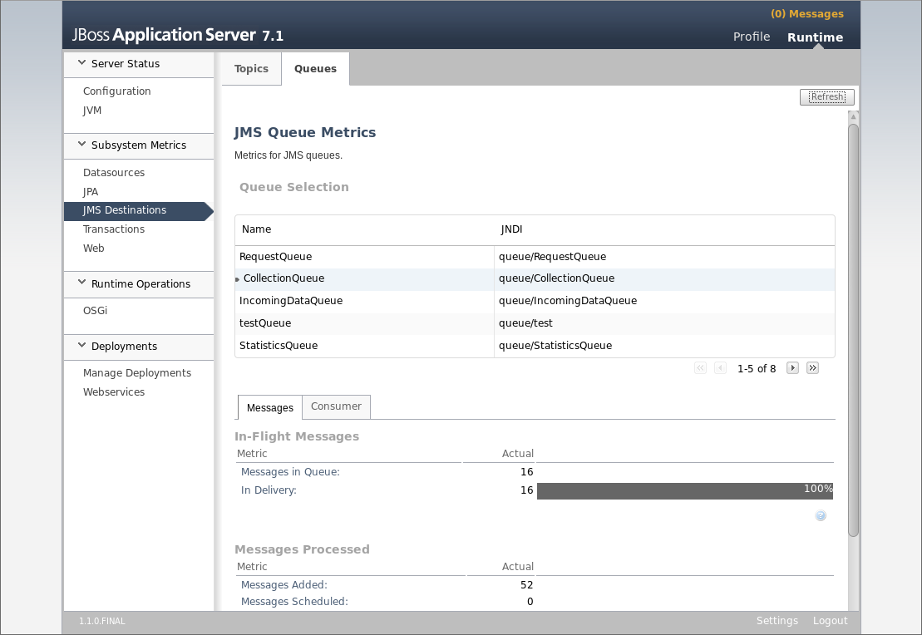

Data Service folders
As mentioned in the deployment section, the Data Service uses some disk folders during the collection process. The number of files in these folders represents the current collection activity and that may be worth to monitor.
In particular:
- harness / incoming: where GTS flow is dropped
- harness / ingesting: where GTS flow is moved after being dispatch (for ingestion and replication)
- harness / working: where batch files are split
- replication / sending / destinations / <TARGET>: links of files to replicate to the corresponding target

Logs and errors
Data and Management Service logs are based on a customization of the standard JBoss logs as mentioned in section 5.1 / ‘Logs configuration’
.

The following alarms are logs in this file:

Event | Severity | Comment
The arrival of critical, high priority data | WARN | A new high priority data (GTS Priority 1 or 2) has been ingested.
The component X is in a degraded state | ERROR | One of the component (Ingestion, Feeding, Replication)
The loss or corruption of data | ERROR | A corrupted data (bad file, wrong format…) has been received and rejected. (in temp folder)
Metadata validation failed | ERROR | The validation of a metadata has failed (insert, harvesting, synchronization)
The ingestion of data for which no metadata record exists | WARN | A high priority (GTS priority 1 or 2) product has been ingested whereas no associated metadata was found. Hence a Stop-Gap metadata has been created.
The size of the data Cache exceeds a defined value | WARN
Dissemination request exceeds a predefined threshold | WARN | A dissemination request for one user request exceeds a predefined threshold.
Number of entries in the DAR catalogue exceeds a defined threshold | WARN | The number of metadata in the catalogue exceeds a pre-defined threshold.
Administrators and Operators fail authentication | WARN | An attempt to authenticate as Administrator or Operator failed.
Unauthorized access attempt to the system from user | WARN | When a user tries to access the system via federation whereas he is not allowed to
Number of registered users exceeds a defined threshold | WARN | When the number of registered users exceeds the threshold
Number of active authenticated users exceeds threshold | WARN | When the number of concurrent authenticated users exceeds the threshold
Number of active anonymous users exceeds a defined threshold | WARN | When the number of concurrent anonymous users exceeds the threshold
Delivery failed on dissemination system | ERROR | Error while trying to disseminate via the Dissemination Harness
Size of products in one Staging Post exceeds threshold | WARN | When the total size of products in Staging Post of one user exceed the threshold
Failure to contact a local data source or when extraction fails | ERROR | Error while trying to access a Local Data Source (dedicated harness)
Harvesting/synchronization task is complete | INFO
User requests an extension of privileges | INFO | A user has requested a privilege extension for accessing (request/subscribe) a specific data

The replication logs include:
- OpenWIS Dispatcher: in /var/opt/openwis/replication/dispatch.log
These logs are very simple and generated by the start_openwis_dispatch.sh.
The log format is as followed: for each dispatched file <date>: <message referring dispatched file>
- FTPReplication: in /var/opt/openwis/replication/ftp-replication.log
These logs are generated by the Log4J framework, and configured in FtpReplication/log4j.properties.
The log format is as followed: %d{ISO8601} %-5p [%c] - %m%n
meaning <date> <level> <category> - <message><line separator>
(Details of pattern layout: http://logging.apache.org/log4j/1.2/apidocs/org/apache/log4j/PatternLayout.html

Portals

Tomcat installation
User and Administration portals, as well as SolR run on Tomcat 7 server. You can download a copy of Tomat 7.0.59 from the project website (or one of the mirrors):
http://archive.apache.org/dist/tomcat/tomcat-7/v7.0.59/bin/apache-tomcat-7.0.59.zip

Once downloaded, perform the following as openwis in the openwis home directory:
unzip apache-tomcat-7.0.59.zip
chmod a+x apache-tomcat-7.0.59/bin/*.sh
cp openwis-dependencies/portals/*.sh .
chmod a+x *.sh

The Tomcat start/stop scripts set the CATALINA_HOME environment variable. If Tomcat is installed in a different location, these scripts will need to be updated.

To add Tomcat as a service to start at boot, as root:
cp ArchivesOpenWIS/tomcat/tomcat /etc/init.d
/sbin/chkconfig –-add tomcat
/sbin/chkconfig tomcat on

Note about user rights and tmp folder
The User and Admin portals are built upon GeoNetwork which may create temporary files in the default temporary folder of the system (/tmp) when performing SRU search. Therefore, the openwis user, which runs Tomcat, needs to be allowed to create files in this folder.
An alternative is to configure Tomcat to use another temp folder by including the following line in start_openwis_tomcat.sh:
CATALINA_TMPDIR=/home/openwis/tmp

Memory adjustment
By default, Tomcat is configured to use a maximum of 512 Mbytes of memory for heap space.
If the host allows more memory allocation, it is recommended to increase this maximum value.
In start_openwis_tomcat.sh:
export CATALINA_OPTS="-Xmx512m -XX:MaxPermSize=256m"
The following parameters may be adjusted: -Xmx represents the maximum of memory usage (‘m’ means Mbytes)

URI Charset Configuration
To allow SolR indexing and querying non ascii characters (e.g. Russian characters), Tomcat (for both portals and Solr) needs to be configured to conform to the URI standard by accepting percent-encoded UTF-8.
Edit Tomcat's conf/server.xml and add the following attribute to the correct Connector element: URIEncoding="UTF-8".
<Server ...>
<Service ...>
<Connector ... URIEncoding="UTF-8"/>
...
</Connector>
</Service>
</Server>

Start / Stop Tomcat
The provided scripts can be used as openwis to start and stop Tomcat:
./start_openwis_tomcat.sh
./stop_openwis_tomcat.sh
The start-up script ‘tomcat’ copied in /etc/init.d can be used to start and stop Tomcat as a normal RedHat service.

Failover considerations
Tomcat (portals and Solr) installation is configured as an active/passive failover.
Install the two Tomcat instances are installed as described above.

Conga configuration
Create a new script resource “tomcat”, referencing the “tomcat” script deployed in /etc/init.d.

- In Active/passive failover:
Configure a new IP address resource, setting a new virtual IP address on which Tomcat will listen to.
Create one service from the tomcat resource and the virtual IP resource.
Configure a failover domain containing the two nodes and relocate as recovery policy to enable automatic failover mechanism between the two nodes.

Configure Tomcat to listen to this virtual IP address:
vi /home/openwis/apache-tomcat-6.0.29/conf/server.xml
Edit the connector element:
<Connector port="8080" protocol="HTTP/1.1"
connectionTimeout="20000"
redirectPort="8443" address="<VIRTUAL_IP_ADDRESS" />

Solr
As root (if not already done):
mkdir /var/opt/openwis
chown –R openwis:openwis /var/opt/openwis

As openwis:
Create the Solr home folder and the Solr data folder:
mkdir /var/opt/openwis/solr
mkdir /var/opt/openwis/solr/data

The SolR war is deployed as followed:
mkdir <TOMCAT_HOME>/webapps/openwis-portal-solr
cd <TOMCAT_HOME>/webapps/openwis-portal-solr
unzip openwis-portal-solr.war -d <TOMCAT_HOME>/webapps/openwis-portal-solr

Finally restart Tomcat

service tomcat restart (or use stop start tomcat scripts provided)

Configuration
The configuration is done in WEB-INF/classes/openwis.properties of the SolR webapp:
(Alternatively this configuration file may be generated by the configuration tool described in section 8)
###
### OpenWIS SolR Configuration
###

### SolR data folder
openwis.solr.data=/var/opt/openwis/solr/data

### Spatial folder (only used in case PostGIS is not available)
openwis.solr.spatial=/var/opt/openwis/solr/spatial

### Database configuration
jdbc.driver=org.postgresql.Driver
jdbc.url=jdbc:postgresql://localhost:5432/OpenWIS
jdbc.user=openwis
jdbc.password=openwis

The SolR data folder can be adjusted if needed.

Spatial indexing
2 possibilities exist for spatial indexing:
- Shape file: When using shape files (and not PostGIS), local files in a dedicated directory will be used to store the spatial information.
Create the SolR spatial directory:
mkdir /var/opt/openwis/solr/spatial
Adjust the related spatial folder in openwis.properties described above (if needed).

Difference with Iteration 2: the shared folder between SolR and Portals are not needed anymore

- PostGIS: when using PostGIS, the spatial information are stored in the common OpenWIS database.
Adjust the database configuration in openwis.properties described above.

Note: When starting up, SolR will first try to connect the database and test if a valid PostGIS installation exists, otherwise it automatically switch to shape file indexing.

Failover considerations
SolR failover is configured as Active/Passive between two instances.
SolR data are replicated between the two instances (using DRBD for example) or managed on a common secured shared device (SAN for example).
Configure a replicated or shared device between the two hosts of SolR. The configuration documentation for DRBD can be found here: http://www.drbd.org/docs/install/.
We assume in the following documentation that the shared or replicated folder is mounted and accessible on /mnt/openwis-solr on both hosts.

Initialize the SolR cluster
As root:
mkdir /mnt/openwis-solr/data
chown openwis:openwis /mnt/openwis-solr/data

Set the SolR data folder as /mnt/openwis-solr/data in openwis.properties described in the previous section.

Conga configuration
Refer to the general Tomcat failover section.
As for Postgres, create a File System resource to mount the directory that will contain the SolR data.
Configure a new service “tomcat-solr” and:
- add the virtual IP address resource
- add the File System resource (or add the DRBD script if needed and add the File System resource as child of the DRBD resource)
- add the tomcat resource as child of the File System resource

Logs and errors
SolR logs are generated by the Log4J framework and configured via the file of the corresponding Web application, in WEB-INF/log4j.properties.
The logs are written on the console appender and so located in Tomcat default log file:
- <home openwis>/apache-tomcat-6.0.29/logs/Catalina.out: all server logs, including SolR ones

Both logs have the following format:
%d{ISO8601} %-5p [%c] - %m%n
meaning <date> <level> <category> - <message><line separator>
(Details of pattern layout: http://logging.apache.org/log4j/1.2/apidocs/org/apache/log4j/PatternLayout.html)

User and Admin portal

Deployment of the Web applications
As openwis:
Deployment of the admin portal:
mkdir apache-tomcat-7.0.59/webapps/openwis-admin-portal
cd apache-tomcat-7.0.59/webapps/openwis-admin-portal
jar xvf openwis-admin-portal.war

Deployment of the user portal:
mkdir apache-tomcat-7.0.59/webapps/openwis-user-portal
cd apache-tomcat-7.059/webapps/openwis-user-portal
jar xvf openwis-user-portal.war

Configuration
The configuration is based on the same file/parameters on user and admin portals.
(If necessary use dos2unix command)

- config.xml: database connection (Geonetwork)
vi WEB-INF/config.xml
In section postgresql, set the user, password and URL used to connect the PostgreSQL instance.
(Alternatively this configuration file may be generated by the configuration tool described in section 8)

- openwis-metadataportal.properties: OpenWIS specific configuation
vi WEB-INF/classes/openwis-metadataportal.properties

(Alternatively this configuration file may be generated by the configuration tool described in section 8)

The following table gives the description each property:
(In grey, the properties that won’t need to be changed on a typical deployment)
openwis.metadataportal.dataservice.*.wsdl | WSDL location of the Data Services  Update with DataService host/port
openwis.metadataportal.securityservice.*.wsdl | WSDL location of the Security Web Services  Update with SecurityService host/port
openwis.metadataportal.harness.subselectionparameters.wsdl | WSDL location of the SubselectionParameters Harness Web Service
openwis.metadataportal.harness.mssfss.wsdl | WSDL location of the MSS/FSS Harness Web Service
openwis.management.*.wsdl | WSDL location of the Security Web Services  Update with ManagementService host/port
openwis.metadataportal.mssfss.support | Whether the MSS/FSS is supported by the current deployment
openwis.metadataportal.url.staging.post | Base URL of the Staging Post
openwis.metadataportal.cache.enable | Whether the current deployment has a Cache facility
openwis.metadataportal.solr.url | SolR location: http://server:port/openwis-portal-solr
openwis.metadataportal.date.format | Date format (test only)
openwis.metadataportal.datetime.format | Date time format (test only)
openwis.metadataportal.deploy.name | Deployment name as defined with Populate LDAP described in section 3.5(e.g. GiscMeteoFrance)
openwis.metadataportal.datapolicy.default.name | Default data policy that will be applied to newly created groups
openwis.metadataportal.datapolicy.default.operations | Default data policy operation that will be applied to newly created groups
openwis.metadataportal.sso | OpenSSO URL (used only on Administration portal)
openwis.metadataportal.oai.maxRecords | Max records processed by OAIPMH in one page
openwis.metadataportal.acceptedFileExtensions | Accepted list of file extensions (deduced from the metadata and used during file unpacking)
openwis.metadataportal.monitoring.userportal.url | URL of user portal used to test availability (used on admin portal)
openwis.metadataportal.monitoring.synchro.warn.limit | Percentage beyond which the availability of synchronization process will be marked in error
openwis.metadataportal.monitoring.harvesting.warn.limit | Percentage beyond which the availability of harvesting process will be marked in error
openwis.metadataportal.session.securityservice.tooManyActiveUsers | Number of connected users beyond which an alarm is raised
openwis.metadataportal.securityservice.tooManyActiveAnonymousUsers | Number of anonymous users beyond which an alarm is raised
openwis.metadataportal.extract.xpath | XPath of the GTS Category / Data Policy in ISO19139 schema
openwis.metadataportal.extract.gtsCategoryAdditionalRegexp | Regular expression to interpret a GTS Category found in metadata as WMOAdditional
openwis.metadataportal.extract.gtsCategoryEssentialRegexp | Regular expression to interpret a GTS Category found in metadata as WMOEssential
openwis.metadataportal.extract.gtsPriorityRegexp | Regular expression to interpret a GTS Priority found in metadata
openwis.metadataportal.extract.urnPatternForIgnoredFncPattern | The pattern applied on URN to determine if FNC Pattern found in metadata should be ignored when inserting the metadata.  Default ignored FNC Pattern when URN is TTAAiiCCCC based)
openwis.metadataportal.catalogsize.alarm.period | Catalog size limit period checking task
openwis.metadataportal.catalogsize.alarm.limit | Catalog size limit beyond which raise an alarm
openwis.metadataportal.lang.list | Available languages: list of <lang_value/lang_label>
openwis.metadataportal.report.file.path | Directory where harvesting reports are stored on the admin portal server

- openwis-deployments.properties: Multi-deployments configuration
vi WEB-INF/classes/openwis-deployments.properties
Alternatively this configuration file may be generated for a basic settings, without backup peers, by the configuration tool described in section 8.

openwis.cots | List of deployment names that can be used to consult the remote requests/subscription.  These deployments must be in the same circle of trust.
openwis.backups | List of backup deployment names
openwis.deployment.url.<DEPLOYMENT_NAME> | The User portal URL of the backup deployment (for each backup deployment, including the current one)
openwis.deployment.url.<DEPLOYMENT_NAME>.admin | The administrator email of the backup deployment (for each backup deployment, including the current one) that will be notified in case of availability error detection
openwis.backup.warn.rate | The rate of available function (in %) bellow which we consider that

Failover considerations
User portal and Admin portal failover is configured as Active/Passive with only one concurrent instance running at a time.
Install the second instance of portal as for the first instance.
The portal will be accessible via the Apache front-end configured to load balance the traffic between the two instances.

Conga configuration
Refer to the general Tomcat failover section.

Portal customization
Extra configuration parameters may be tuned to customize the portals deployment.

Internationalization
To include / configure a language, the following parameters need to be considered:
- openwis-metadataportal.properties: the property openwis.metadataportal.lang.list allows the define the list of languages available on the portal selection combo box
- openwisMessage.properties: Java properties containing messages generated by the server
- <webapp>/scripts/Openwis/lib/Openwis/Lang/Locales/<language_key>.js: contains most of the internationalized OpenWIS labels
- <webapp>/loc//<language_key>/xml/: contains help and about pages, and internationalization coming from GeoNetwork

Advanced Search by default
On User Portal main page, a configuration parameter allows to the Advanced Search panel at first, instead of the Simple Search panel (default behaviour).
In header-homepage.jsp: set showAdvancedSearchFirst to true.

Export AS WMO core profile
OpenWIS allows to define a custom export from one schema to WMO core profile, by providing the proper XSL.
To setup such an export, the following modifications need to be performed on each portal Web application:
- Update the file WEB-INF/config-export.xml to declare a new GeoNetwork service for the export; the XML file contains a commented version of a typical service declaration for this purpose (section ‘Metadata export services : Export AS WMO core profile’)
- Update the files WEB-INF/adminPortal-profiles.xml and WEB-INF/userPortal-profiles.xml to authorize this service for user profiles (as mentioned in config-export.xml)
- Add the XSL file to the Web application in xsl/conversion/export with the following format: xml_<schema-name>_to_19139.xsl

CheckAuthorization service
For centres that does not provide CheckAuthorization service, the following configuration change needs to be performed for the user and admin portal:
Delete the following line to WEB-INF/userPortal-profiles.xml (for the user portal) and WEB-INF/adminPortal-profiles.xml to prevent access to this service for the Guest profile:
<allow service="xml.CheckAuthorization"/>

CRON purge
The purge of portal log files and harvest reports is done by CRON commands. Purge time, period and folders may be adjusted if needed.
Edit the crontab, as openwis:
crontab -e

# Remove portal logs older than 7 days at 00:15
00 15 * * * /usr/bin/find /home/openwis/logs/*.log* -mtime +6 -exec rm {} \;
# Remove harvesting logs older than 7 days at 00:30
30 00 * * * /usr/bin/find <REPORTS_DIR>/harvest-*.txt -mtime +7 -exec rm {} \;

Logs and errors
Portals logs are generated by the Log4J framework and configured via the file of the corresponding Web application, in WEB-INF/log4j.cfg.
The logs are:
- <home openwis>/logs/openwis.log: all server logs
- <home openwis>/logs/metadata.log: logs related to metadata operations
Both logs have the following format:
%d{ISO8601} %-5p [%c] - %m%n
meaning <date> <level> <category> - <message><line separator>
(Details of pattern layout: http://logging.apache.org/log4j/1.2/apidocs/org/apache/log4j/PatternLayout.html)

Staging Post
The Staging Post is a file system accessible via a Web interface.
This can be configured using the provided StagingPost web application deployed on a Tomcat server or alternatively deployed on JBoss.
As mentioned in data service section, the Staging Post file system is configured to be in /var/opt/openwis/stagingPost.

As openwis:
Deployment of the Staging Post web app:
mkdir /var/opt/openwis/stagingPost (if needed)
cd /var/opt/openwis/stagingPost
jar xvf stagingPost.war

In case the Staging Post is deployed elsewhere, adjust the Staging Post globalXsltFile locations in WEB-INF/web.xml.

To deploy Staging Post on Tomcat:
Edit the server.xml file of Tomcat:
vi apache-tomcat-7.0.59/conf/server.xml
Add the following element to the Host element:
<Context docBase="/var/opt/openwis/stagingPost" path="/stagingPost" reloadable="false"/>

To deploy Staging Post on JBoss:
Create a link named stagingPost.war in the JBoss deploy folder, targeting the Staging Post folder:
cd /home/openwis/EnterprisePlatform-5.1.0/jboss-eap-5.1/jboss-as/server/production/deploy
ln –s /var/opt/openwis/stagingPost/ stagingPost.war

Failover considerations
Staging Post failover is configured as Active/Passive with two instances configured and only one running.
Install the second instance of Staging Post as for the first instance.
Staging Post data are replicated between the two instances (using DRBD for example) or managed on a common secured shared device (SAN for example).
We assume in the following documentation that the shared or replicated folder is mounted and accessible on /mnt/openwis-stagingpost on both hosts.

Initialize the Staging Post cluster
As root:
mkdir /mnt/openwis-stagingpost/
chown openwis:openwis /mnt/openwis-solr/

Conga configuration
Refer to the general Tomcat failover section.
Create a File System resource to mount the directory that will contain the Staging Post data.
Configure a new service “tomcat-stagingpost” and:
- add the virtual IP address resource
- add the File System resource (or add the DRBD script if needed and add the File System resource as child of the DRBD resource)
- add the tomcat resource as child of the File System resource

Apache Frontend
An Apache server is used as a front-end to access:
- the user and admin portals
- OpenAM
- OpenWIS Security Services (load balancing/failover)
- Data Service (load balancing/failover)
- the Staging Post

Apache is already installed by default in RedHat 5.5.

The configuration of Apache is done via the configuration file: /etc/httpd/conf/httpd.conf.
The relevant section is:
<IfModule mod_proxy.c>

Start Apache Web Server:
service httpd start

Notes:
Enable SELinux working with Apache Proxy
setsebool httpd_can_network_connect on
To test the value
getsebool httpd_can_network_connect
httpd_can_network_connect --> on

Configuration for OpenAM
Warning:
- If failover and site are not configured : the host name of the proxied OpenAM needs to be exactly the same as used during OpenAM installation (hostname and not IP address) or the whole OpenAM installation needs to be done via the front-end host name.
- In failover and site configuration: the frontend hostname will be the frontend of the configured site.

For a simple front-end configuration:
ProxyPreserveHost On

# Proxy for OpenAM
ProxyPass /opensso http://<HOST_OPENAM>:8080/opensso
ProxyPassReverse /opensso http://<HOST_OPENAM>:8080/opensso

For a failover configuration with load balancing between 2 OpenAM instances:

ProxyRequests Off

# Load balancer for OpenAM
<Proxy balancer://cluster-opensso>
Order deny,allow
Allow from all

BalancerMember http://<HOST_OPENAM_1>:8080/opensso route=node1
BalancerMember http://<HOST_OPENAM_2>:8080/opensso route=node2
ProxySet lbmethod=byrequests
ProxySet stickysession= APLBCOOKIE
</Proxy>

Header add Set-Cookie "APLBCOOKIE=APACHE.%{BALANCER_WORKER_ROUTE}e;path=/;" env=BALANCER_ROUTE_CHANGED
ProxyPass /opensso balancer://cluster-opensso
ProxyPassReverse /opensso http://<HOST_OPENAM_1>:8080/openam
ProxyPassReverse /opensso http://<HOST_OPENAM_2>:8080/openam

Configuration for IdPDiscovery
For a simple front-end configuration:
# Proxy for IDP Discovery
ProxyPass /idpdiscovery http://<HOST_IDP_DISCOVERY>:8080/idpdiscovery
ProxyPassReverse /idpdiscovery http://<HOST_IDP_DISCOVERY>:8080/idpdiscovery

For a failover configuration with load balancing between 2 IdpDiscovery instances:
# IDP Discovery
<Proxy balancer://cluster-idpdiscovery>
Order deny,allow
Allow from all

BalancerMember http://<HOST_IDPDISCOVERY_1>:8080/idpdiscovery route=node1
BalancerMember http://<HOST_IDPDISCOVERY_2>:8080/idpdiscovery route=node2
</Proxy>

ProxyPass /idpdiscovery balancer://cluster-idpdiscovery lbmethod=byrequests
ProxyPassReverse /idpdiscovery http://<HOST_IDPDISCOVERY_1>:8080/idpdiscovery
ProxyPassReverse /idpdiscovery http://<HOST_IDPDISCOVERY_2>:8080/idpdiscovery

Configuration for OpenWIS Security Service
When configuring failover for OpenWIS Security Web Services, the Apache frontend is used as load balancer between the 2 Tomcat instances (used for OpenAM).
The Apache configuration is as followed:
# Security service Loadbalancer
<Proxy balancer://cluster-securityservice>
Order deny,allow
Allow from all

BalancerMember http://<HOST_OPENAM_1>:8080/openwis-securityservice route=node1
BalancerMember http://<HOST_OPENAM_2>:8080/openwis-securityservice route=node2
</Proxy>

ProxyPass /openwis-securityservice balancer://cluster-securityservice lbmethod=byrequests
ProxyPassReverse /openwis-securityservice http://<HOST_OPENAM_1>:8080/openwis-securityservice
ProxyPassReverse /openwis-securityservice http://<HOST_OPENAM_2>:8080/openwis-securityservice

Configuration for Portals

ProxyPreserveHost On

# Proxy for User portal
ProxyPass /openwis-user-portal http://<HOST_USER_PORTAL>:8080/openwis-user-portal
ProxyPassReverse /openwis-user-portal http://<HOST_USER_PORTAL>:8080/openwis-user-portal

# Proxy for Admin portal (if admin portal is available on this zone)
ProxyPass /openwis-admin-portal http://<HOST_ADMIN_PORTAL>:8080/openwis-admin-portal
ProxyPassReverse /openwis-admin-portal http://<HOST_ADMIN_PORTAL>:8080/openwis-admin-portal

Replace HOST_USER_PORTAL and HOST_ADMIN_PORTAL by the virtual address used for the Active/Passive configuration.

Redirect /
It’s generally useful to be able to access the application without having to precise the name of the web application and just give the hostname; for example: using http://wispi.meteo.fr instead of http://wispi.meteo.fr/openwis-user-portal to access the user portal.
This can be configured with the following Redirect directive:
Redirect / http://<HOST_USER_PORTAL:PORT>/openwis-user-portal

Or similarly for Admin portal:
Redirect / http://<HOST_ADMIN_PORTAL:PORT>/openwis-admin-portal

Configuration for Staging Post

ProxyPass /stagingPost http://<HOST_STAGINGPOST_WEBAPP>:8080/stagingPost
ProxyPassReverse /stagingPost http://<HOST_STAGINGPOST_WEBAPP>:8080/stagingPost

For Staging Post failover, replace HOST_STAGINGPOST_WEBAPP by the virtual address used for the Active/Passive configuration.

Optimizing Javascript transfer
Apache front-end can be configured to optimize the Javascript transfer, by supplying gzipped version of some Javascript files (the biggest one, located in scripts/lib and scripts/Openwis).
Here is an example of the front-end configuration:

<Location / >

RewriteEngine on
RewriteCond %{HTTP:Accept-Encoding} =gzip,deflate
RewriteRule ext-all\.js /ext-all.jgz [L]
RewriteRule OpenLayers\.js /OpenLayers.jgz [L]
RewriteRule OpenwisHomePage\.js /OpenwisHomePage.jgz [L]
RewriteRule OpenwisCommon\.js /OpenwisCommon.jgz [L]

AddType "text/javascript;charset=UTF-8" .jgz
AddEncoding gzip .jgz

</Location>

<Directory / >
Options Indexes FollowSymLinks
order allow,deny
allow from all
</Directory>

Using HTTPS
The pre-requisite is to deploy a valid certificate as well as a private key. These file are generally dropped in /etc/pki/tls/certs/ and /etc/pki/tls/private/.
To configure HTTPS in Apache, a Virtual Host needs to be defined.
The RedHat default installation provides such a built-in configuration file that may be re-used in /etc/httpd/conf.d/ssl.conf.
Edit this file to configure access to the certificate and the private key:

<VirtualHost _default_:443>
…
SSLEngine on
…
SSLCertificateFile /etc/pki/tls/certs/<MY_CERTIFICATE>.crt
SSLCertificateKeyFile /etc/pki/tls/private/<MY_PRIVATE_KEY>.key

All the components that have to be accessed via HTTPS must also be configured in this Virtual Host, via the definition of ProxyPass directives.
These directives are the same as described in the previous sections, except for OpenAM. Indeed, in this case OpenAM requires the use of AJP proxy instead of the basic HTTP proxy.
So the OpenAM proxy directives needs to be set as followed:

# Proxy for OpenAM (over SSL)
ProxyPass /opensso ajp://<HOST_OPENAM>:8180/opensso
ProxyPassReverse /opensso ajp://<HOST_OPENAM>:8180/opensso

Once the Virtual Host and Proxy directives configured, all the OpenWIS components will be accessible via HTTPS instead of HTTP.

Firewall considerations
Solr uses the standard Tomcat HTTP port: 8080.
Solr must be accessible to the portals.

The portals use the following ports:
- the standard Tomcat HTTP port: 8080

The portal must be accessible to:
- the final user or the apache front-end
- external portals for: harvesting, synchronization (standard HTTP port)

The front-end uses the following ports:
- the standard Apache HTTP port: 80
The front-end must be accessible to:
- the final user

Configuration tool
The OpenWIS distribution provides a configuration tool that generates the configuration files needed for each component.
To use it:
cd /home/openwis/openwis-dependencies/config

Edit the file configuration.properties and fills the expected values.
Generate the configuration file:
./GenerateConfiguration.sh

The configuration files are generated in deploy directory with the following structure:
+ adminportal: configuration files for the Administration portal
+ dataservice: configuration files for Data Service (JNDI, data source)
+ replication: configuration files for the replication (JGroups / Vuze)
+ securityservice: configuration files for Security Service (JNDI, including LDAP connection)
+ solr: configuration files for the SolR (openwis.properties)
+ userportal-public: configuration files for the User portal / public (Internet) side
+ userportal-rmdcn: configuration files for the User portal / private (RMDCN) side

APPLICABLE and REFERENCE Documents (A/R)

A/R | Reference | Title
A1 | SSD-OPENWIS-001 | Software Specification Dossier
A2 | DD-OpenWIS-1 | Design Dossier

GLOSSARY AND ACRONYMS

Glossary
Term | Definition
Alarm | An alarm is a warning message raised as a result of a predefined event. An event is what has happened, and the alarm is the warning to the operator.
Additional Data | Additional Data are Global data, which must be accessible all around the world via GISC Systems on conditions. They are subject to specific data policies imposed by the producer NC or DCPC
Centre | Deployment of OpenWIS assuming one WIS role.
Circle Of Trust (COT) | Set of systems that trust each other and can exchange authentication and authorization information to enable Single Sign-On and Federation
Data Policy | defines a set of privileges related to products for locally defined user groups
Dataset | A dataset is a collection of geo-referenced spatial data (or products)
Essential Data | Essential Data are Global data, which must be publicly accessible all around the world via GISC Systems
Global Data | The Global Data are composed of Essential Data and Additional Data. Global Data must be replicated all around the world thanks to ‘Replication’ mechanism between GISCs
Local Data | Local Data are not accessible around the world via GISC systems. They are accessible at their producer NC or DCPC, and may be subject to specific data policies
Product instance | Individual occurrence of a data or product
Site | Set of several OpenWIS deployments (Centres) alternatively sharing resources (including Security Service)
Staging Post | Accessible file repository used to distribute requested products
Virtual GISC | 2 GISCs (Météo-France and UKMO) that proposes a common view of mutual services and a set of common users. In OpenWIS, a Virtual GISC implies Backup scenario and Single Sign-On capacity between the two involved GISCs
Virtual Organisation | Deployment of several roles (GISC, DCPC, NC) on one Site or across Sites, as described above.

Abbreviations
Abbreviation | Description
DAR | Discovery Access Retrieval
DCPC | Data Collection and Production Centre
DISS | Dissemination System
FNC | File Naming Convention
FTP | File Transfer Protocol
GISC | Global Information System Centre
GTS | Global Telecommunication System
GUI | Graphical User Interface
IdP | Identity Provider
MEF | Metadata Export Format
MSS/FSS | Message or File Switching System that allows Partners to exchange data via a private resilient network, the Global Telecommunication System (GTS).
NC | National Centre
RMDCN | Existing private Wide Area Network on which all Meteorological Centre are connected
SLA | Software Level Agreement
SSO | Single Sign-On
URN | Uniform Resource Name
WIS | WMO Information System
WMO | World Meteorological Organization
XML | eXtensible Mark-up Language
XSL | eXtensible Style sheet Language

Appendix

Data Service configuration – Advanced Parameters
The following parameters are advanced or internal parameters and should not need to be modified on a typical deployment.

extraction.timer.url | JNDI name of the ExtractionTimerService (this should not be changed)
extraction.timer.period | [ms] Initial delay and period for the ExtractionTimerService
subscription.timer.url | JNDI name of the SubscriptionTimerService (this should not be changed)
subscription.timer.period | [ms] Initial delay and period for the SubscriptionTimerService
localDataSource.polling.timer.url | JNDI name of the LocalDataSourcePollingTimerService (this should not be changed)
localDataSource.polling.timer.period | [ms] Initial delay and period for the LocalDataSourcePollingTimerService
cache.provider.url | Obsolete
cache.service.url | JNDI name of the Extraction Service (this should not be changed)
processedRequest.service.url | JNDI name of the ProcessedRequestService (this should not be changed)
extractionDelegate.url | JNDI name of the ExtractionDelegate Service (this should not be changed)
cache.gts.collection.splittingTimerService.url | JNDI name of the Splitting Timer Service (this should not be changed)
cache.gts.collection.collectionTimerService.url | JNDI name of the Collection Timer Service (this should not be changed)
metadata.service.url | JNDI name of the ProductMetadata Service (this should not be changed)
metadata.service.provider.url | Obsolete
cache.cacheManager.url | JNDI name of the Cache Manager (this should not be changed)
cache.cacheIndex.url | JNDI name of the Cache Index (this should not be changed)
cache.feeder.url | JNDI name of the Feeder (this should not be changed)
cache.cacheManager.purgeTimer.initialDelay | [ms] The initial delay of the Temporary Directory Purging Timer
cache.cacheManager.housekeepingTimer.initialDelay | [ms] The initial delay of the Cache Housekeeping Timer
cache.cacheManager.alertCleanerTimer.initialDelay | [ms] The initial delay of the Alert Cleaner Timer
cache.cacheManager.purgeTimer.initialDelay | [ms] The initial delay of the Purge Timer for the temporary directory
cache.gts.collection.collectionTimer.initialDelay | [ms] The initial delay of the Collection Timer
cache.gts.collection.splittingTimer.initialDelay | [ms] The initial delay of the Splitting Timer.
cache.gts.collection.splittingTimer.period | [ms] The period of the Splitting (unpack packed bulletins) Timer.
cache.cacheManager.purgeTimer.period | [ms] The period of the Purge Timer for the temporary directory
cache.gts.feeding.packedFeedingTimerService.url | JNDI name of the Packed Feeding Timer Service (this should not be changed)
cache.gts.feeding.packedFeedingTimer.initialDelay | [ms] The initial delay of the Packed Feeding Timer.
cache.gts.feeding.packedFeedingTimer.period | [ms] The period of the Packed Feeding Timer.
cache.gts.util.databaseAccessor.url | JNDI name of the database accessor bean, used by the File Packer.
cache.gts.feeding.config.maximumMessageCount | The maximum number of files that go into a single WMO FTP package
cache.gts.collection.exclude.patterns | The file extensions of files which will be excluded during the Collection and Splitting process [ext_1; ext_2; … ; ext_n;]
cache.gts.collection.include.patterns | The file extensions of files which will be included during the Collection and Splitting process [ext_1; ext_2; … ; ext_n;]
cache.gts.collection.include.max | The number of files the Collection and Splitting process will evaluate during a single timeout occurrence
cache.dissemination.disseminationTimer.initialDelay | [ms] The initial delay of the Dissemination Manager and the Dissemination Status Monitor
cache.dissemination.disseminationTimer.period | [ms] The period of the Dissemination Manager Timer and the Dissemination Status Monitor
cache.dissemination.sla.factor.gold | Weight factor for prioritizing gold products during the dissemination process (should be greater then the corresponding silver value)
cache.dissemination.sla.factor.silver | Weight factor for prioritizing silver products during the dissemination process (should be greater then the corresponding bronze value)
cache.dissemination.sla.factor.bronze | Weight factor for prioritizing bronze products during the dissemination process
cache.gts.collection.include.max | The number of file the Collection and Splitting process will evaluate during a single timeout occurrence
cache.gts.collection.include.patterns | The file extensions of files which will be included during the Collection and Splitting process [ext_1; ext_2; … ; ext_n]
cache.gts.collection.exclude.patterns | The file extensions of files which will be excluded during the Collection and Splitting process [ext_1; ext_2; … ; ext_n]
cache.gts.feeding.config.maximumMessageCount | The maximum number of files that go into a single WMO FTP package
cache.config.numberOfChecksumBytes | The number of bytes of a file on which the checksum will be calculated
cache.dissemination.stagingPost.purgeTime | [minutes] The entries in the “StagingPostEntry” database table and the files on the staging post, referenced in those entries, which are older than this value will be deleted.
cache.dissemination.disseminationTimer.period | [ms] The period of the Dissemination Manager Timer and the Dissemination Status Monitor
cache.dissemination.disseminationTimer.initialDelay | [ms] The initial delay of the Dissemination Manager and the Dissemination Status Monitor
cache.cacheManager.housekeepingTimer.expirationWindow | [days] The number of days the cache content will be valid before it gets removed
cache.cacheManager.housekeepingTimer.period | [ms] The period of the Cache Housekeeping Timer
cache.cacheManager.alertCleanerTimer.period | [ms] The period of the Alert Cleaner Timer
cache.cacheManager.alertCleanerTimer.expirationWindow | [days] The number of days an alarm will be valid before it gets removed
cache.cacheManager.purgeTimer.period | [ms] The period of the Temporary Directory Purging Timer
cache.gts.collection.splittingTimer.period | [ms] The initial delay of the Temporary Directory Purging Timer
cache.gts.collection.splittingTimer.initialDelay | [ms] The period of the Temporary Directory Purging Timer
cache.gts.collection.collectionTimer.period | [ms] The period of the Collection Timer
cache.cacheManager.purgeTimer.initialDelay | [ms] The initial delay of the Temporary Directory Purging Timer
cache.cacheManager.housekeepingTimer.initialDelay | [ms] The initial delay of the Cache Housekeeping Timer
cache.gts.collection.collectionTimer.initialDelay | [ms] The initial delay of the Collection Timer
cache.dissemination.disseminationHarness.public.url | The URL of the public dissemination harness
cache.dissemination.disseminationHarness.rmdcn.url | The URL of the RMDCN dissemination harness
mail.transport.protocol | smtp

